**Differentiate between PHP5 and PHP7.**

1. **Performance:**
   * **PHP 5:** PHP 5 had performance limitations and was relatively slower compared to later versions.
   * **PHP 7:** PHP 7 introduced significant performance improvements. It included the Zend Engine 3.0, which made PHP 7 up to twice as fast as PHP 5.6 for many applications. This improvement was achieved through better memory usage and optimizations in the core engine.
2. **Scalar Type Declarations:**
   * **PHP 5:** PHP 5 allowed type hinting for class/interface types, but it didn't support scalar type declarations (int, float, string, bool).
   * **PHP 7:** PHP 7 introduced scalar type declarations, which allow you to specify the expected data types for function parameters and return values. You can use **int**, **float**, **string**, and **bool** as type hints.
3. **Return Type Declarations:**
   * **PHP 5:** PHP 5 did not support return type declarations for functions.
   * **PHP 7:** PHP 7 introduced return type declarations, which allow you to specify the expected data type that a function should return. You can use **: returnType** after the function declaration.
4. **Spaceship Operator (<=>):**
   * **PHP 5:** The spaceship operator (**<=>**) was not available in PHP 5.
   * **PHP 7:** PHP 7 introduced the spaceship operator for comparing two values, making it easier to implement custom sorting and comparison functions.
5. **Null Coalescing Operator (??):**
   * **PHP 5:** The null coalescing operator (**??**) was not available in PHP 5.
   * **PHP 7:** PHP 7 introduced the null coalescing operator, which provides a concise way to handle potentially null values.
6. **Anonymous Classes:**
   * **PHP 5:** PHP 5 did not support anonymous classes.
   * **PHP 7:** PHP 7 introduced support for anonymous classes, allowing you to define classes on the fly without explicitly naming them.
7. **Error Handling:**
   * **PHP 5:** PHP 5 used traditional error handling with **mysql\_error()**, **mysql\_errno()**, and **die()**.
   * **PHP 7:** PHP 7 introduced a more consistent and improved error handling mechanism using exceptions. It also introduced the Throwable interface for better exception handling.
8. **Improved Type Hinting:**
   * **PHP 5:** PHP 5 had limited support for type hinting, primarily for class and interface types.
   * **PHP 7:** PHP 7 expanded type hinting capabilities, including scalar type hints, return type hints, and improved support for custom types through interfaces and classes.
9. **Deprecated Features:**
   * **PHP 5:** PHP 5 included many features and functions that were deprecated and removed in later versions.
   * **PHP 7:** PHP 7 removed several deprecated features and improved the consistency of the language.
10. **Unicode Support:**
    * **PHP 5:** PHP 5 had limited support for Unicode, making handling multibyte character encodings challenging.
    * **PHP 7:** PHP 7 improved Unicode support and introduced functions for working with multibyte strings more effectively.
11. **New Operators and Functions:**
    * **PHP 5:** PHP 5 introduced some operators and functions, but the additions were more significant in PHP 7.
12. **Compatibility:**
    * **PHP 5:** PHP 5 had a substantial user base and many existing applications running on it.
    * **PHP 7:** PHP 7 aimed to maintain backward compatibility with PHP 5 while introducing new features. However, some older code might require modifications to run on PHP 7.

**Types of Error in php**

1. **Parse Errors:**
   * Parse errors occur during the parsing phase of PHP script execution, often due to syntax errors in the code.
   * These errors prevent the script from running and typically include messages like "syntax error, unexpected token."
2. **Fatal Errors:**
   * Fatal errors are severe issues that cause the script to terminate abruptly.
   * Examples include calling an undefined function or accessing an undefined class.
   * Fatal errors cannot be caught or handled within the script.
3. **Warnings:**
   * Warnings are non-fatal errors that don't halt script execution but indicate potential issues.
   * For example, using an uninitialized variable or including a file that doesn't exist.
4. **Notices:**
   * Notices are less severe than warnings and are often related to variables that are used without being explicitly initialized.
   * While notices don't halt script execution, they should be addressed to ensure correct behavior.
5. **Errors Triggered by User-defined Functions:**
   * These errors can occur within user-defined functions or methods.
   * Developers can use the **trigger\_error()** function to generate custom errors and exceptions within their code.
6. **Exceptions:**
   * Exceptions are a more advanced error-handling mechanism introduced in PHP 5.
   * They allow for structured error handling using **try**, **catch**, **finally**, and **throw** statements.
   * Exceptions can be categorized into two main types:
     + **Built-in Exceptions:** PHP provides several built-in exception classes, such as **Exception**, **InvalidArgumentException**, **RuntimeException**, etc.
     + **Custom Exceptions:** Developers can define their own custom exception classes to handle specific application-level errors.
7. **Deprecated Features:**
   * Deprecated features are functions, classes, or methods that are marked as deprecated and may be removed in future PHP versions.
   * Using deprecated features generates warnings to encourage developers to update their code.
8. **Compile-time Errors:**
   * Compile-time errors occur during the compilation phase before script execution.
   * These errors include issues like referencing a non-existent class or extending a final class.
9. **Execution-time Errors:**
   * Execution-time errors occur during script execution and may be triggered by various runtime conditions.
   * Examples include division by zero, accessing an undefined array index, or exceeding memory limits.
10. **Assertion Errors:**
    * Assertions are used to test conditions during development and are typically disabled in production.
    * When an assertion fails, an **AssertionError** is thrown, indicating a logical error in the code.
11. **Database Errors:**
    * These errors occur when interacting with a database using database extensions like MySQLi or PDO.
    * Examples include connection errors, query errors, and data retrieval errors.
12. **HTTP Errors:**
    * HTTP errors are not PHP-specific but may be relevant when dealing with web applications.
    * Examples include HTTP status codes like 404 (Not Found) or 500 (Internal Server Error).

**LAMP Setup**

Setting up a LAMP (Linux, Apache, MySQL, PHP) stack on a server involves installing and configuring the necessary components to host web applications or websites. Here are the steps to set up a LAMP stack on a Linux server:

**1. Provision a Linux Server:**

1. Choose a Linux distribution such as Ubuntu, CentOS, or Debian for your server.

2.Rent a virtual private server (VPS) from a hosting provider or set up a physical server, if applicable.

**2. Connect to the Server:**

Access your server via SSH using a terminal or an SSH client. Replace **your\_server\_ip** with the actual IP address of your server.

cssCopy code

ssh username@your\_server\_ip

**3. Update the System:**

Before installing any software, update the package list and upgrade installed packages to ensure you have the latest security updates.

sqlCopy code

sudo apt update sudo apt upgrade

**4. Install Apache Web Server:**

Install the Apache web server using the package manager for your Linux distribution. For example, on Ubuntu:

Copy code

sudo apt install apache2

**5. Start and Enable Apache:**

Start the Apache service and enable it to start automatically on boot.

bashCopy code

sudo systemctl start apache2 sudo systemctl enable apache2

**6. Test Apache:**

Open a web browser and enter your server's IP address. You should see the default Apache test page, indicating that Apache is running.

**7. Install MySQL (or MariaDB):**

Install the MySQL or MariaDB database server. MariaDB is a drop-in replacement for MySQL and is often used in modern LAMP setups.

Copy code

sudo apt install mariadb-server

**8. Secure MySQL (Optional but Highly Recommended):**

Run the MySQL secure installation script to set a root password and improve security.

Copy code

sudo mysql\_secure\_installation

**9. Install PHP:**

Install PHP and necessary PHP modules for your web applications.

Copy code

sudo apt install php php-mysql

**10. Test PHP:**

Create a PHP info file to test PHP installation. Create a file named **info.php** in the web server's document root (usually **/var/www/html**) with the following content:

phpCopy code

<?php phpinfo(); ?>

Access **http://your\_server\_ip/info.php** in a web browser to see PHP information.

**11. Configure Apache for PHP:**

To enable Apache to process PHP files, you may need to configure Apache to use the PHP module. On Ubuntu, it's usually enabled by default. On other distributions, you might need to enable it manually.

**12. Create and Host Your Web Applications:**

Upload your web application files to the appropriate directory (usually **/var/www/html**) and configure Apache virtual hosts if needed.

**13. Secure Your Server:**

1.Implement firewall rules (e.g., using UFW or iptables) to restrict access to your server.

2.Keep software up to date, apply security patches, and follow best practices for server security.

**14. Optional: Install phpMyAdmin (Database Management Tool):**

If you need a web-based interface for managing MySQL/MariaDB databases, you can install phpMyAdmin. Be sure to secure it properly.

That's it! You now have a basic LAMP stack set up on your server. You can expand upon this setup by installing additional PHP modules, configuring Apache virtual hosts, and securing your web applications as needed.

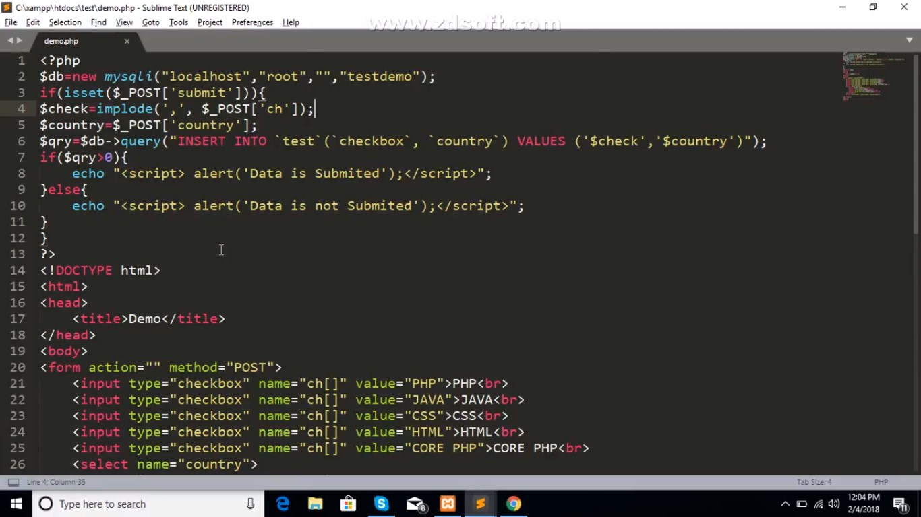

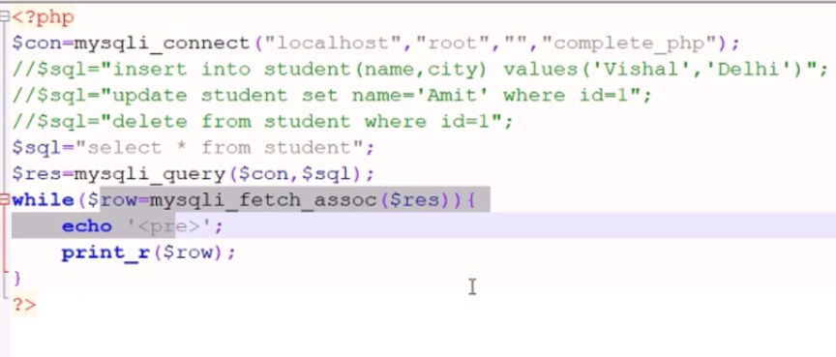

**Select Insert**

Reference Cyber variye youtube chanel <https://www.youtube.com/watch?v=UNFdrhu_5GU&list=PLejKBGxF74J67G7KSGHA4JPOKW9H3cQq3&index=9>

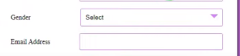

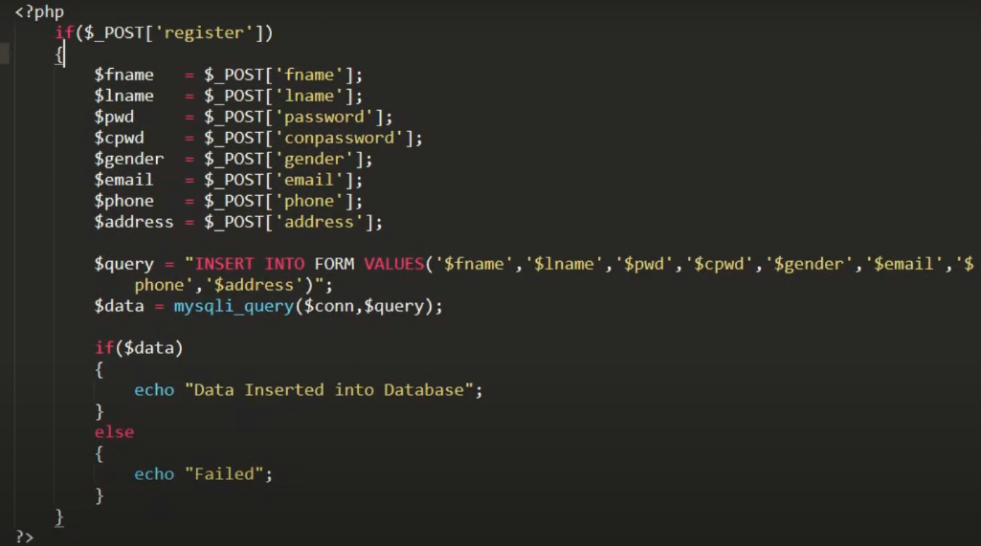

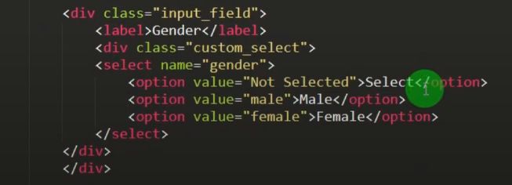

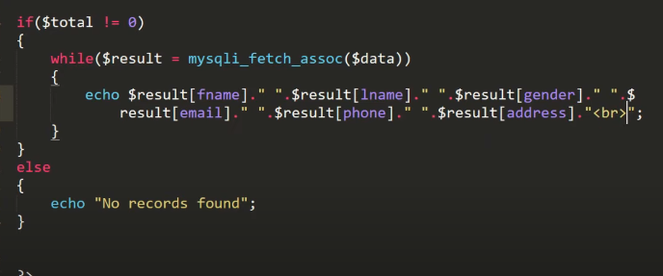

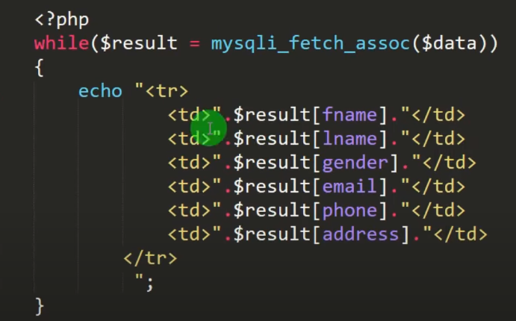

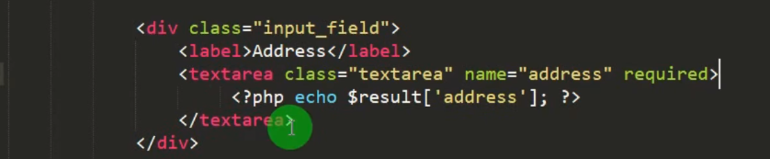

**Updated**

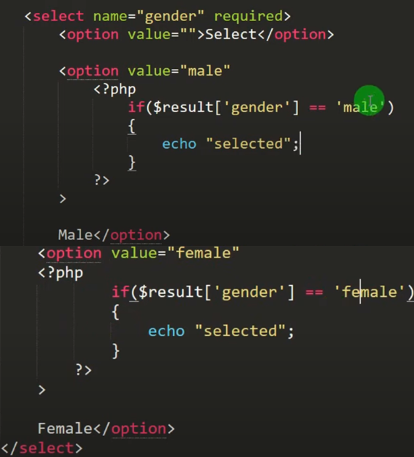

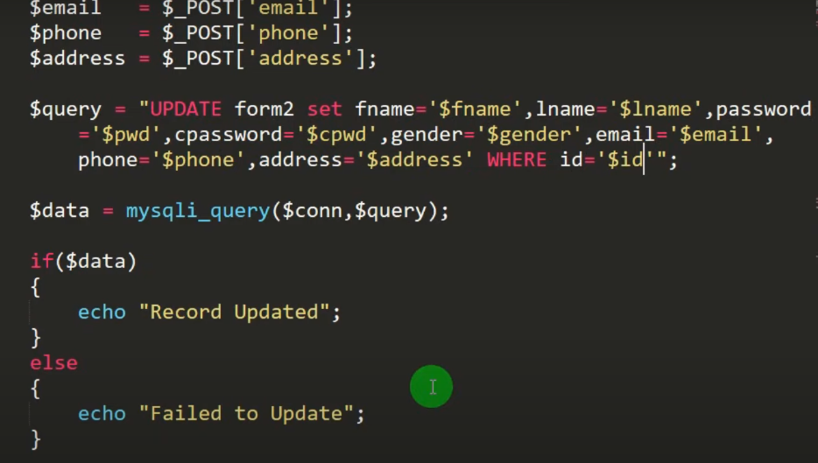

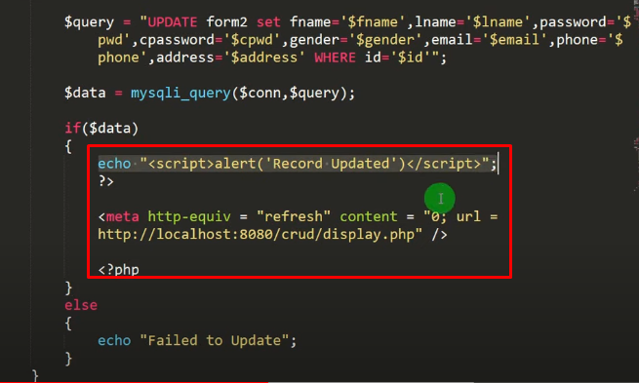

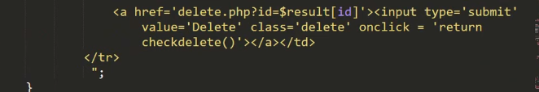

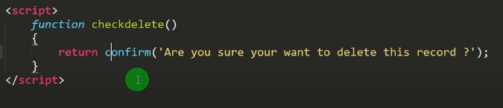

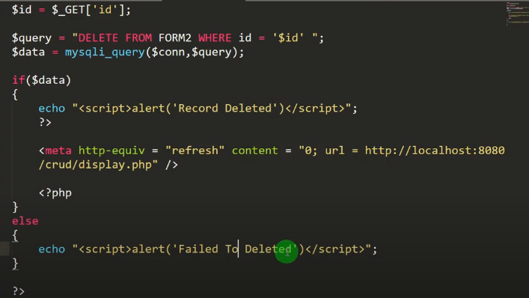

**Redio**

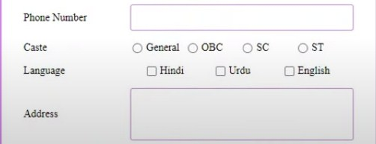

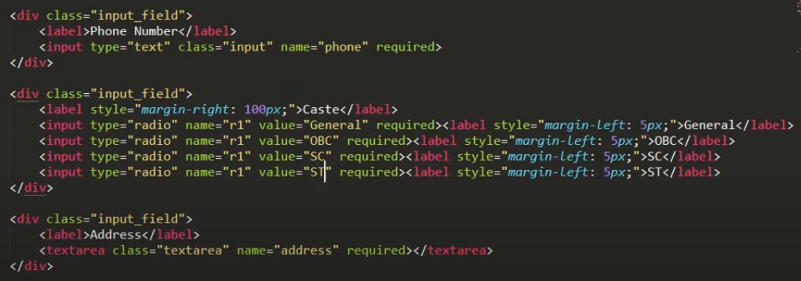

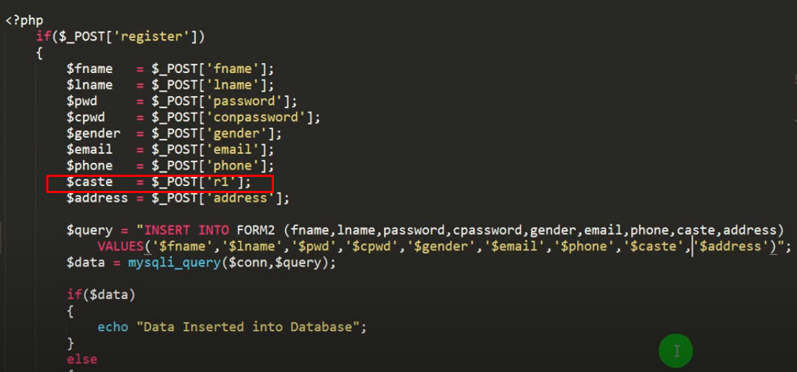

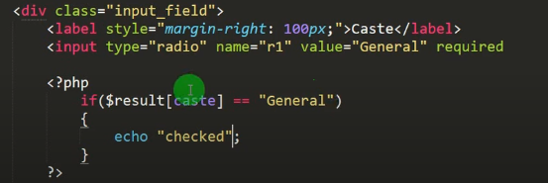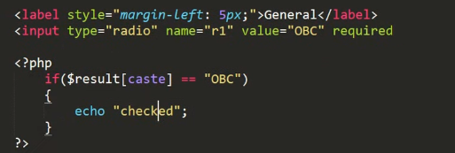

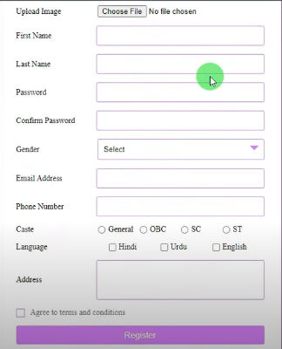

**Checkbox**

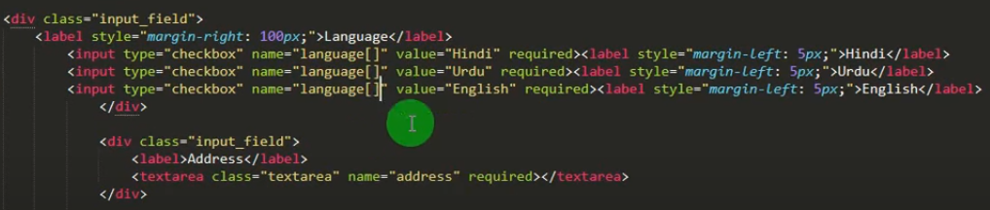

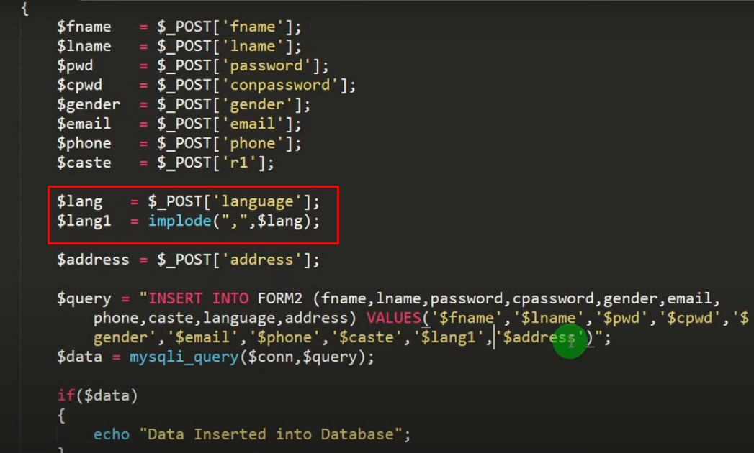

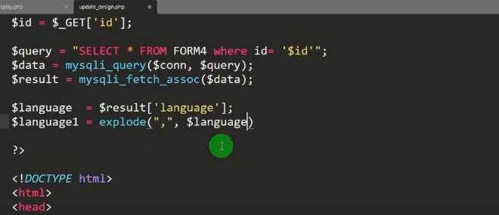

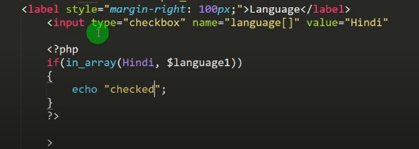 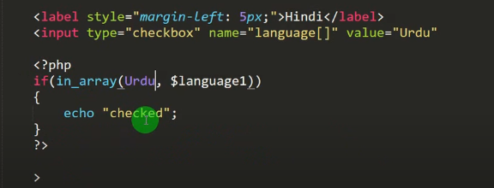

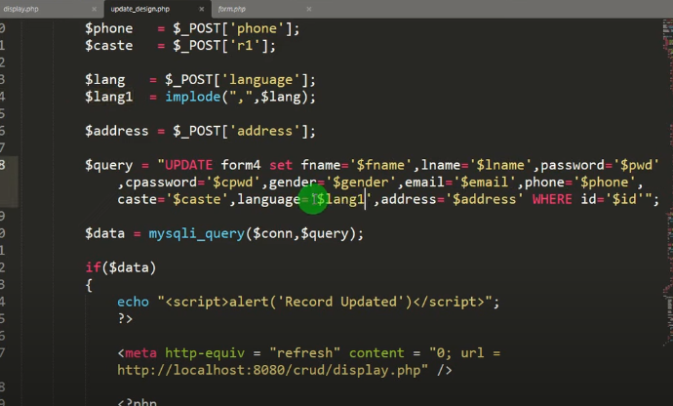

After Insert data Redirection

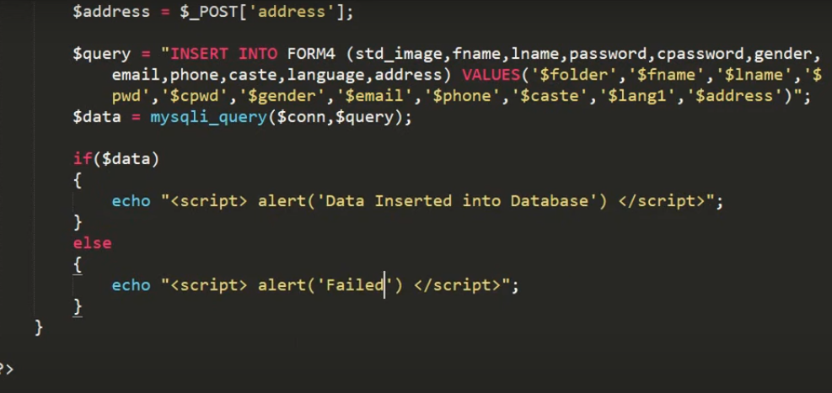

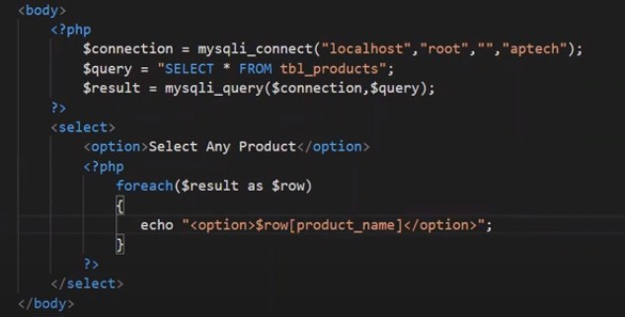

**File Upload**

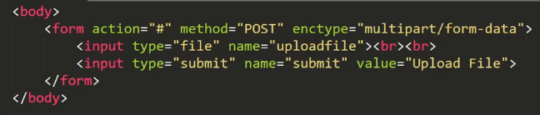 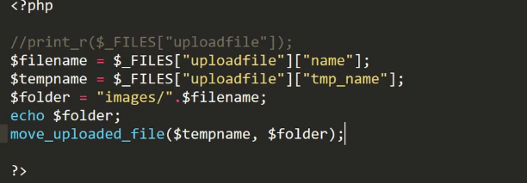

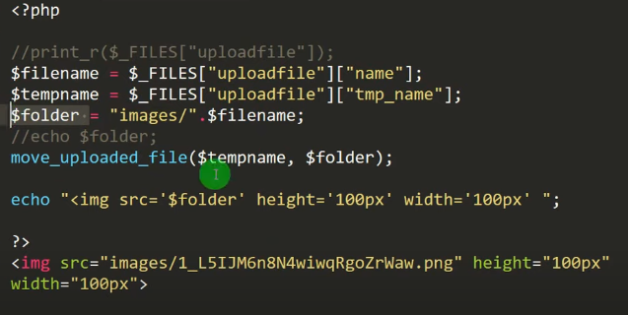

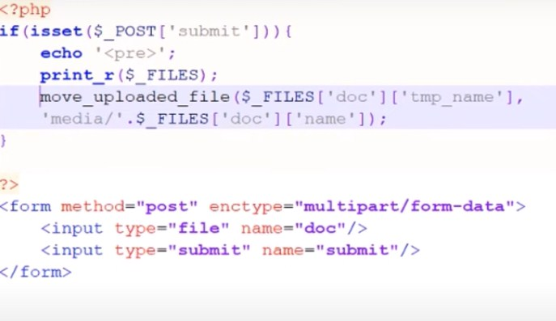

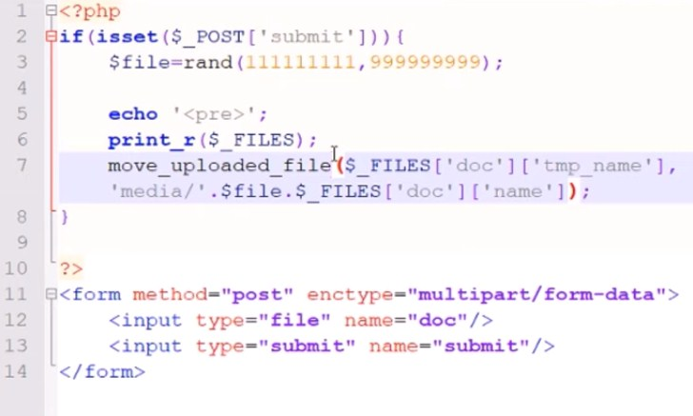

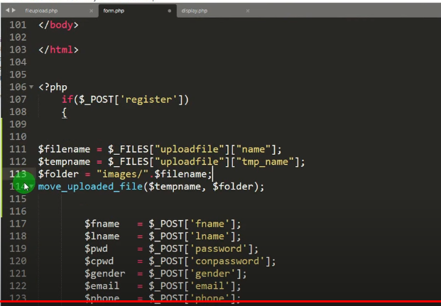 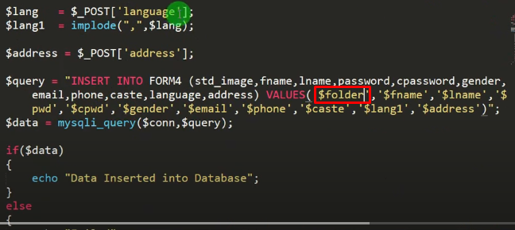

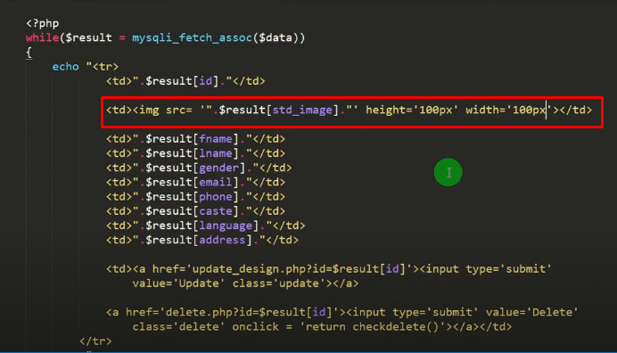

# PHP file upload

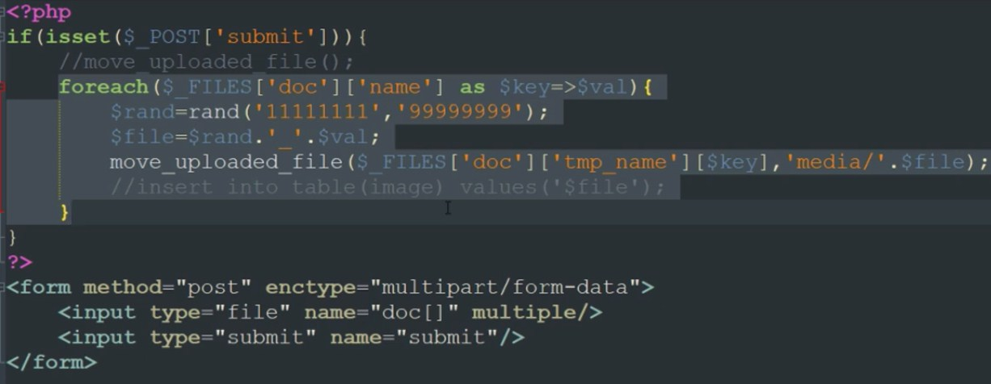

# PHP oops file upload

### upload.php

<?php

class upload{

public $src = "./upload/";

public $tmp;

public $filename;

public $type;

public $uploadfile;

public function startupload(){

$this -> filename = $\_FILES["file"]["name"];

$this -> tmp = $\_FILES["file"]["tmp\_name"];

$this -> uploadfile = $src . basename($this -> name);

}

public function uploadfile(){

if(move\_uploaded\_file($this -> tmp, $this -> uploadFile)){

return true;

}

}

}

?>

#### index.php

<?php

require\_once('./lib/upload.php');

?>

<?php

if(isset($\_POST['file'])){

$fileupload = new upload();

if($fileupload -> uploadfile()){

echo 'Success';

}

}

?>

<html>

<head></head>

<body>

<form align="center" enctype="multipart/form-data" action="<?php echo htmlspecialchars($\_SERVER["PHP\_SELF"]); ?>" method="post">

Select upload file: <input type="file" name="file" required="yes" />

<input type="submit" value="Submit" />

<p>

</form>

</body>

</html>

**Upload Multiple file**

[**https://www.studentstutorial.com/php/file-upload-in-php-mysql**](https://www.studentstutorial.com/php/file-upload-in-php-mysql)

<!DOCTYPE html>

<html>

<head>

<title>File Upload</title>

</head>

<body>

<form action="upload.php" method="post" enctype="multipart/form-data">

<input type="file" name="file" />

<button type="submit" name="upload">upload</button>

</form>

</body>

</html>

**upload.php**

<?php

include\_once 'database.php';

if(isset($\_POST['upload']))

{

$file = rand(1000,100000)."-".$\_FILES['file']['name'];

$file\_loc = $\_FILES['file']['tmp\_name'];

$file\_size = $\_FILES['file']['size'];

$file\_type = $\_FILES['file']['type'];

$folder="upload/";

/\* new file size in KB \*/

$new\_size = $file\_size/1024;

/\* new file size in KB \*/

/\* make file name in lower case \*/

$new\_file\_name = strtolower($file);

/\* make file name in lower case \*/

$final\_file=str\_replace(' ','-',$new\_file\_name);

if(move\_uploaded\_file($file\_loc,$folder.$final\_file))

{

$sql="INSERT INTO image(file,type,size) VALUES('$final\_file','$file\_type','$new\_size')";

mysqli\_query($conn,$sql);

echo "File sucessfully upload";

}

else

{

echo "Error.Please try again";

}

}

?>

**For Multiple File**

<!DOCTYPE html>

<html lang="en" >

<head>

<meta charset="UTF-8">

<title>Multiple image upload</title>

</head>

<body>

<form method="post" action="process.php">

<input type="file" name="image[]" multiple="multiple" >

<p align="center"><button type="submit" class="btn btn-warning" id="butsave">Submit<span class="glyphicon glyphicon-send"></span></button></p>

</form>

</body>

</html>

#### process.php

<?php

$output\_dir = "upload/";/\* Path for file upload \*/

$fileCount = count($\_FILES["image"]['name']);

for($i=0; $i < $fileCount; $i++)

{

$RandomNum = time();

$ImageName = str\_replace(' ','-',strtolower($\_FILES['image']['name'][$i]));

$ImageType = $\_FILES['image']['type'][$i]; /\*"image/png", image/jpeg etc.\*/

$ImageExt = substr($ImageName, strrpos($ImageName, '.'));

$ImageExt = str\_replace('.','',$ImageExt);

$ImageName = preg\_replace("/\.[^.\s]{3,4}$/", "", $ImageName);

$NewImageName = $ImageName.'-'.$RandomNum.'.'.$ImageExt;

$ret[$NewImageName]= $output\_dir.$NewImageName;

/\* Try to create the directory if it does not exist \*/

if (!file\_exists($output\_dir . $last\_id))

{

@mkdir($output\_dir . $last\_id, 0777);

}

move\_uploaded\_file($\_FILES["image"]["tmp\_name"][$i],$output\_dir.$last\_id."/".$NewImageName );

/\*$insert\_img = "insert into `category\_images` SET `category\_ads\_id`='".$category\_ads\_id\_image."', `image`='".$NewImageName."'";

$result = $dbobj->query($insert\_img);\*/

}

echo "Image Uploaded Successfully";

?>

**Pagination Vishal**

**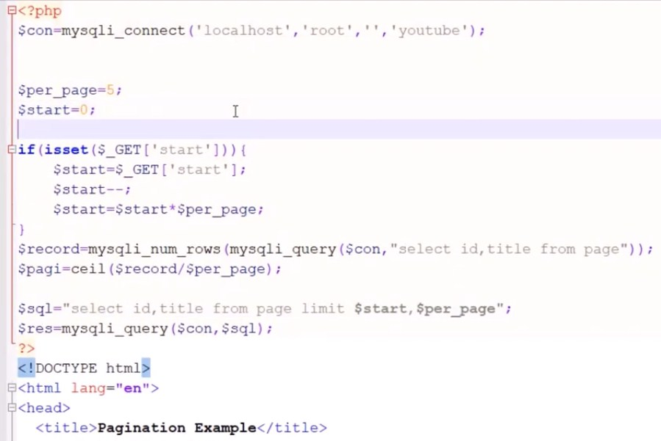**

**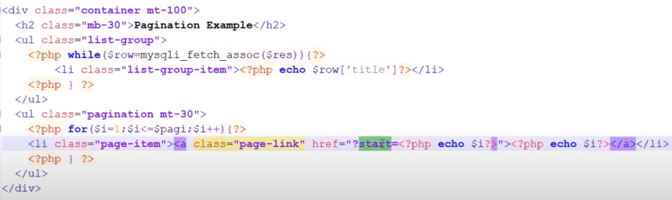**

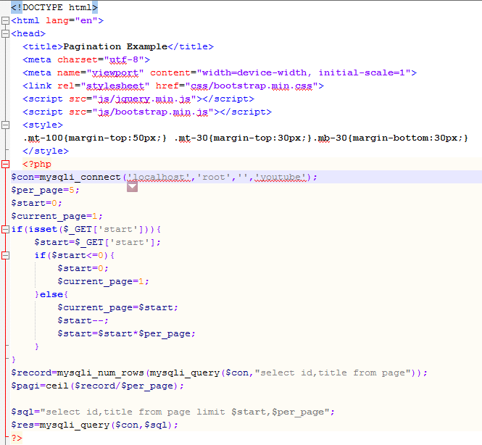

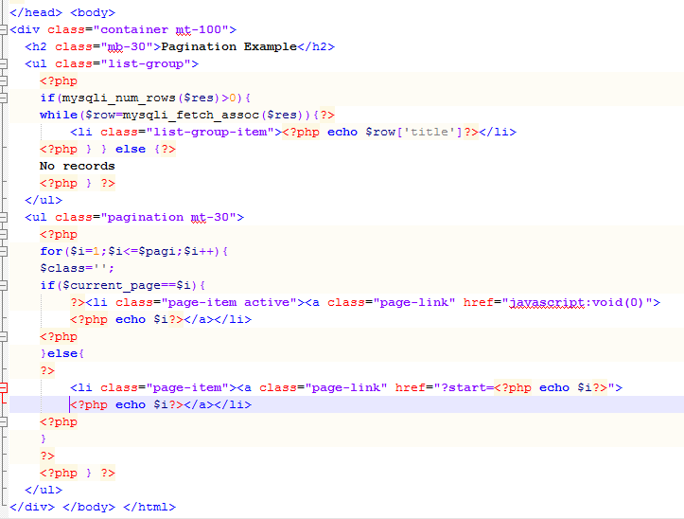

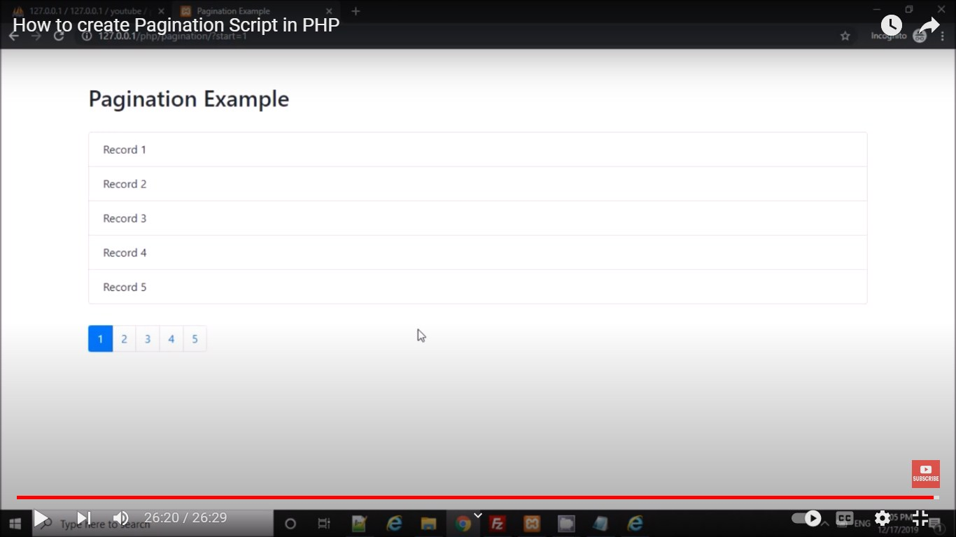

<https://www.youtube.com/watch?v=t0gBYc7QEU8>

<!DOCTYPE html>

<html lang="en">

<head>

  <title>Pagination Example</title>

  <meta charset="utf-8">

  <meta name="viewport" content="width=device-width, initial-scale=1">

  <link rel="stylesheet" href="css/bootstrap.min.css">

  <script src="js/jquery.min.js"></script>

  <script src="js/bootstrap.min.js"></script>

  <style>

  .mt-100{margin-top:50px;} .mt-30{margin-top:30px;}.mb-30{margin-bottom:30px;}

  </style>

  <?php

$con=mysqli\_connect('localhost','root','','youtube');

$per\_page=5;

$start=0;

$current\_page=1;

if(isset($\_GET['start'])){

    $start=$\_GET['start'];

    if($start<=0){

        $start=0;

        $current\_page=1;

    }else{

        $current\_page=$start;

        $start--;

        $start=$start\*$per\_page;

    }

}

$record=mysqli\_num\_rows(mysqli\_query($con,"select id,title from page"));

$pagi=ceil($record/$per\_page);

$sql="select id,title from page limit $start,$per\_page";

$res=mysqli\_query($con,$sql);

?>

</head>

<body>

<div class="container mt-100">

  <h2 class="mb-30">Pagination Example</h2>

  <ul class="list-group">

    <?php

    if(mysqli\_num\_rows($res)>0){

    while($row=mysqli\_fetch\_assoc($res)){?>

        <li class="list-group-item"><?php echo $row['title']?></li>

    <?php } } else {?>

    No records

    <?php } ?>

  </ul>

  <ul class="pagination mt-30">

    <?php

    for($i=1;$i<=$pagi;$i++){

    $class='';

    if($current\_page==$i){

        ?><li class="page-item active"><a class="page-link" href="javascript:void(0)"><?php echo $i?></a></li><?php

    }else{

    ?>

        <li class="page-item"><a class="page-link" href="?start=<?php echo $i?>"><?php echo $i?></a></li>

    <?php

    }

    ?>

    <?php } ?>

  </ul>

</div>

</body>

</html>

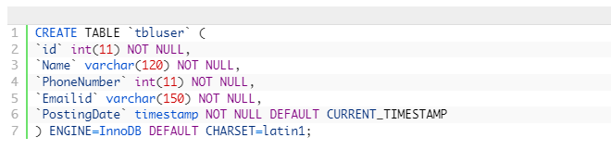

**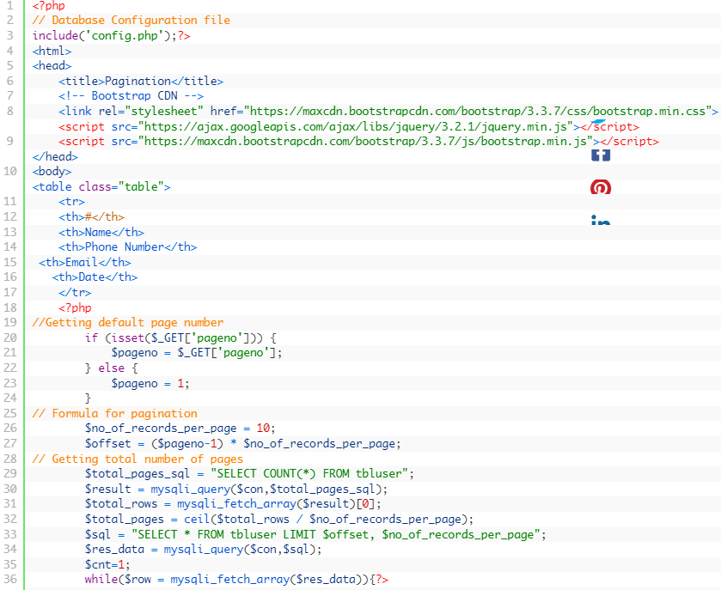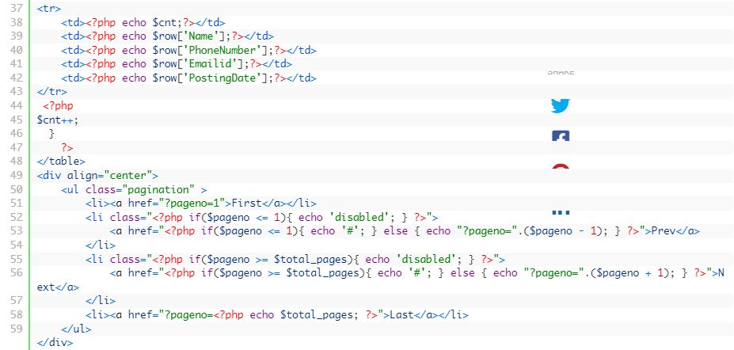**

**Paypal Integration in PHP**

**Step 1: Create a PayPal Business Account**

If you don't already have a PayPal business account, you need to create one. This account will allow you to receive payments.

**Step 2: Get PayPal API Credentials**

PayPal API Username

PayPal API Password

PayPal API Signature

**Step 3: Set Up Your PHP Application**

In your PHP application, create a form to collect payment information from users. Here's a simplified example of a payment form:

**<!DOCTYPE html>**

**<html>**

**<head>**

**<title>Pay with PayPal</title>**

**</head>**

**<body>**

**<h2>Pay with PayPal</h2>**

**<form action="process\_payment.php" method="post">**

**<input type="hidden" name="cmd" value="\_xclick">**

**<input type="hidden" name="business" value="your-paypal-email@example.com">**

**<input type="hidden" name="item\_name" value="Product Name">**

**<input type="hidden" name="item\_number" value="123">**

**<input type="hidden" name="amount" value="10.00">**

**<input type="hidden" name="currency\_code" value="USD">**

**<input type="hidden" name="return" value="http://your-website.com/thank-you.php">**

**<input type="submit" name="submit" value="Pay with PayPal">**

**</form>**

**</body>**

**</html>**

**Step 4: Create a PHP Script to Process Payments (process\_payment.php)**

**<?php**

**$paypal\_url = 'https://www.sandbox.paypal.com/cgi-bin/webscr'; // Use the sandbox URL for testing**

**// PayPal API credentials**

**$paypal\_email = 'your-paypal-email@example.com'; // Your PayPal business email**

**$paypal\_currency = 'USD';**

**// Collect payment data from the form**

**$item\_name = $\_POST['item\_name'];**

**$item\_number = $\_POST['item\_number'];**

**$amount = $\_POST['amount'];**

**// Build PayPal request parameters**

**$fields = [**

**'cmd' => '\_xclick',**

**'business' => $paypal\_email,**

**'item\_name' => $item\_name,**

**'item\_number' => $item\_number,**

**'amount' => $amount,**

**'currency\_code' => $paypal\_currency,**

**'return' => 'http://your-website.com/thank-you.php', // Redirect URL after payment**

**];**

**// Prepare the query string**

**$query\_string = http\_build\_query($fields);**

**// Redirect to PayPal to complete the payment**

**header("location:$paypal\_url?$query\_string");**

**exit();**

**?>**

**Step 5: Handle the PayPal Response**

**Step 6: Test in the PayPal Sandbox**

**PHP program with a trait and a class that uses that trait:**

**<?php**

**// Define a trait called Logger**

**trait Logger {**

**public function log($message) {**

**echo "Logging: $message\n";**

**}**

**}**

**// Create a class that uses the Logger trait**

**class MyClass {**

**use Logger;**

**public function someMethod() {**

**$this->log("This is a log message from MyClass");**

**}**

**}**

**// Create another class that uses the Logger trait**

**class AnotherClass {**

**use Logger;**

**public function anotherMethod() {**

**$this->log("This is a log message from AnotherClass");**

**}**

**}**

**// Create instances of MyClass and AnotherClass**

**$obj1 = new MyClass();**

**$obj2 = new AnotherClass();**

**// Call methods that use the log method from the trait**

**$obj1->someMethod();**

**$obj2->anotherMethod();**

**?>**

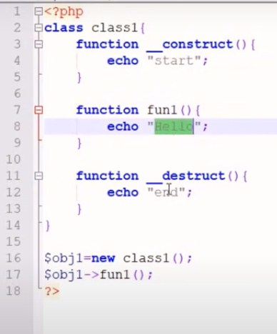 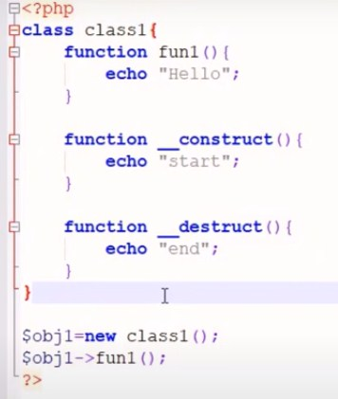

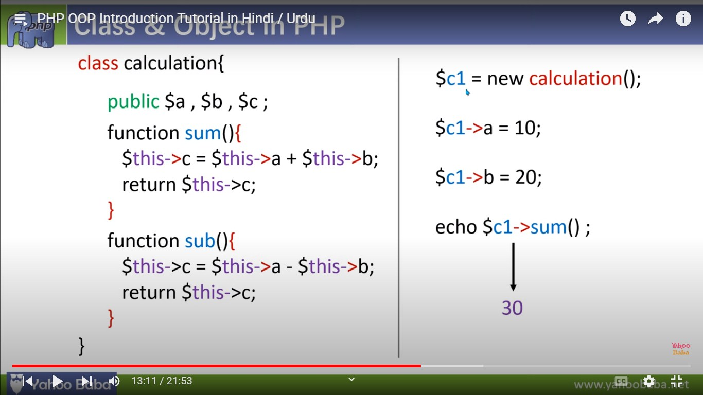

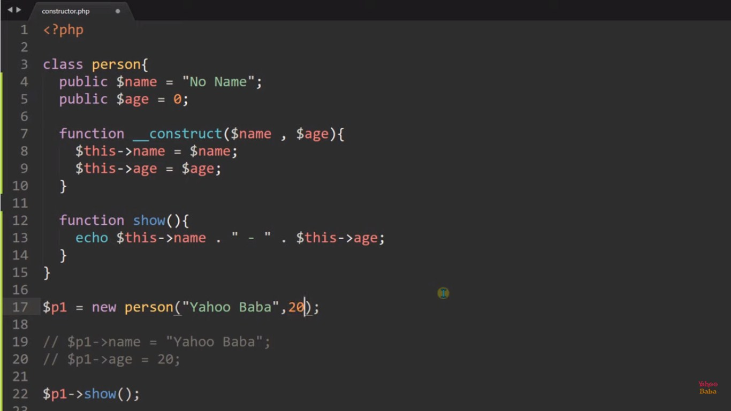

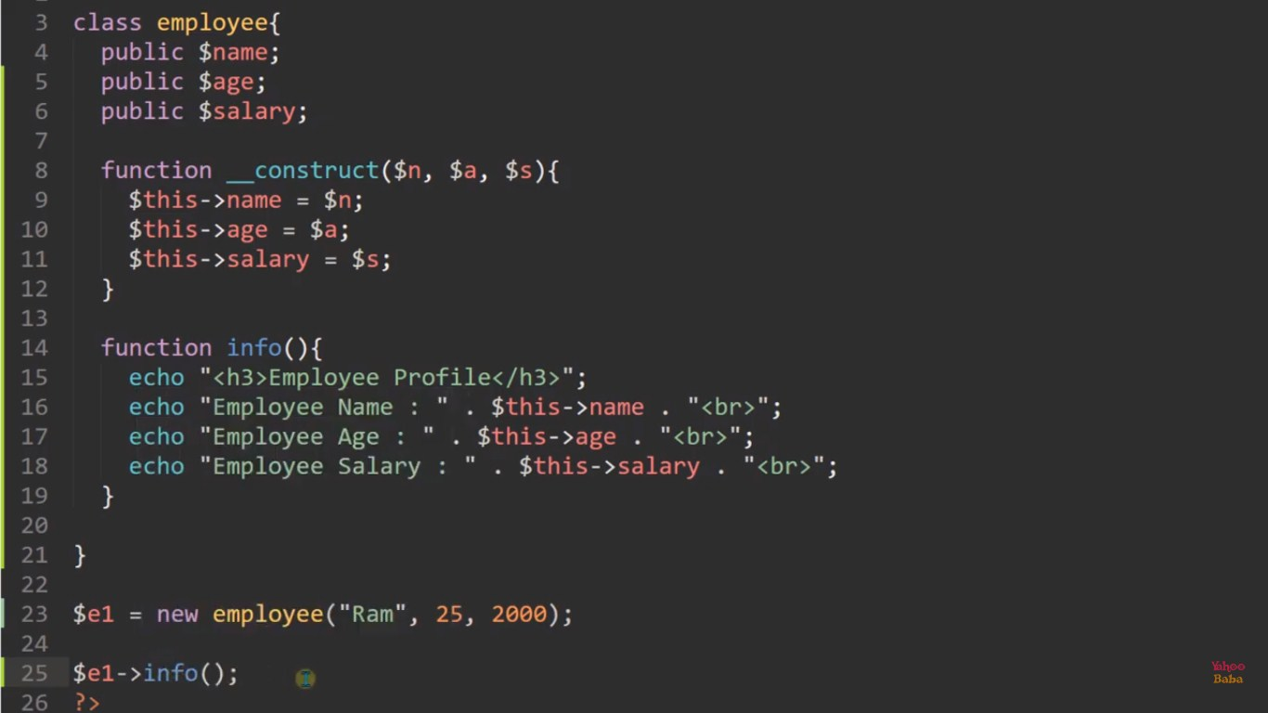

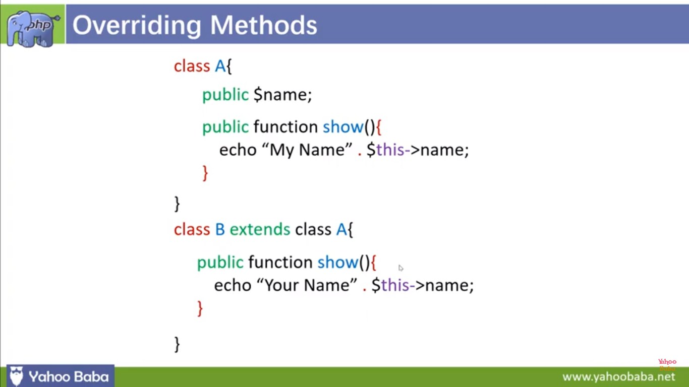

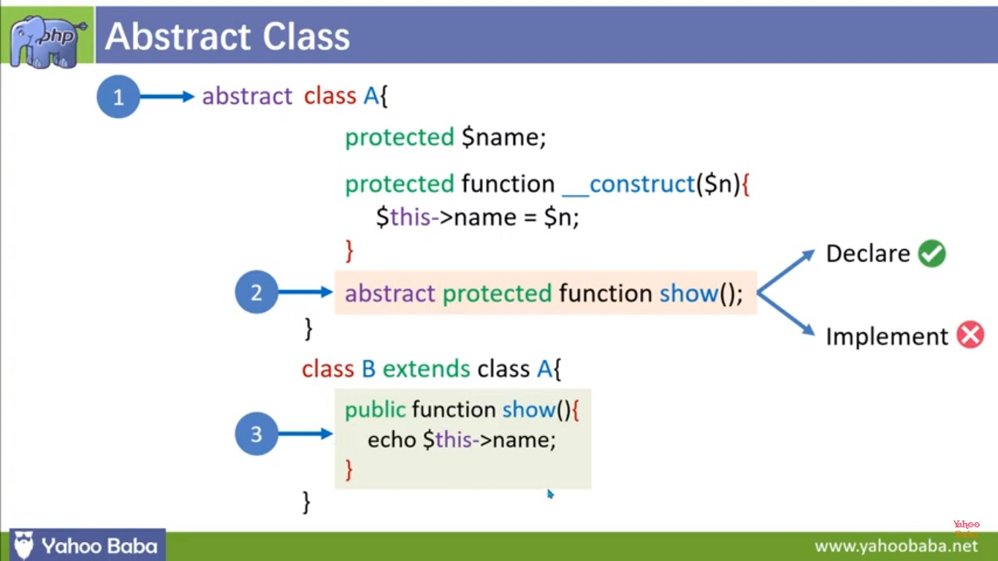

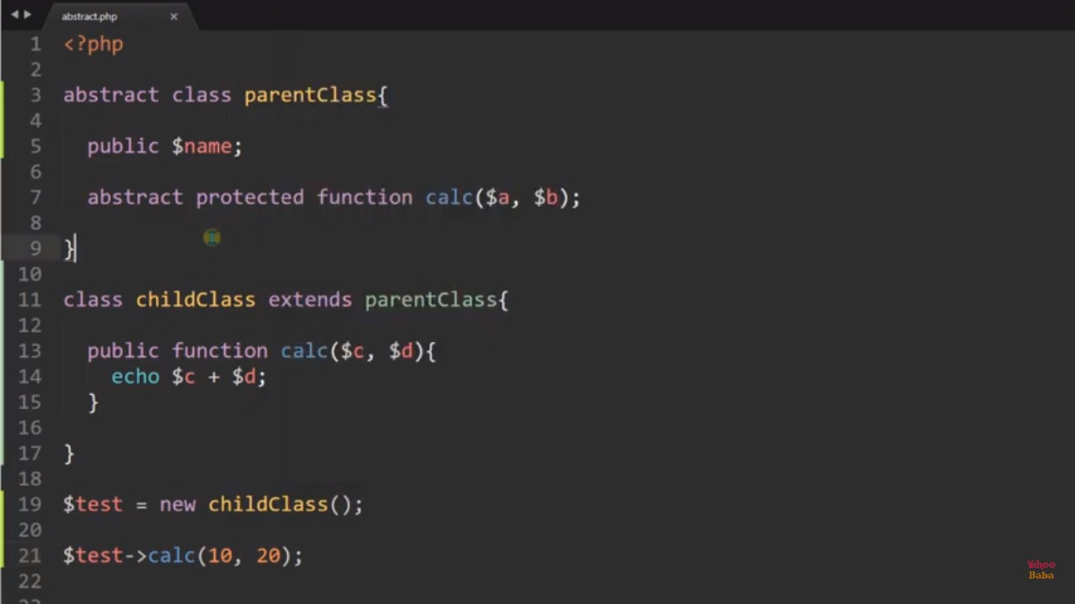

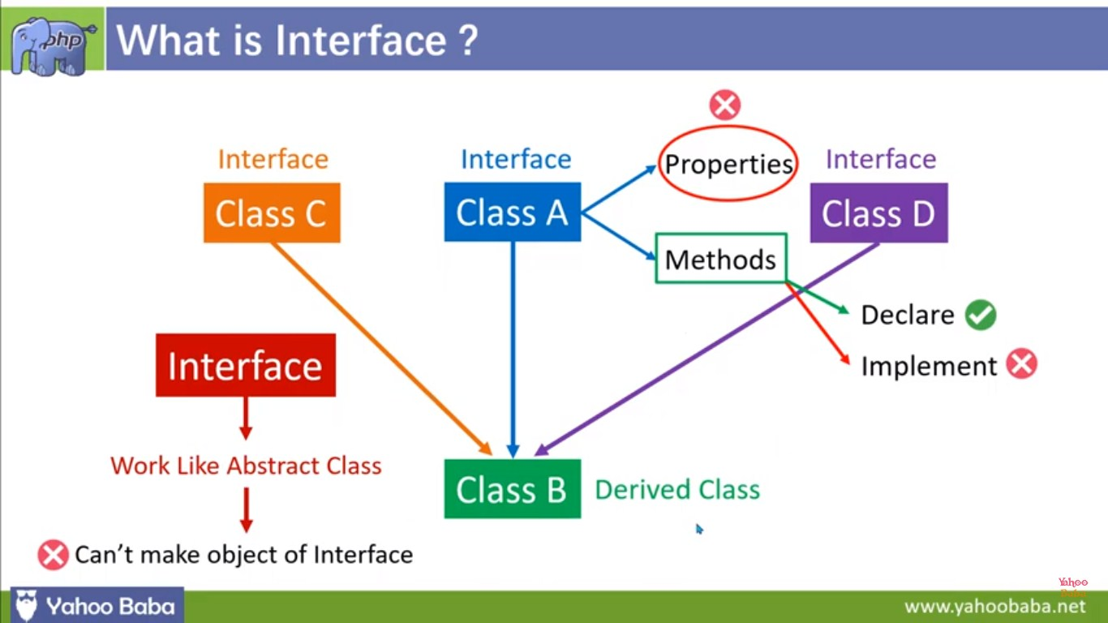

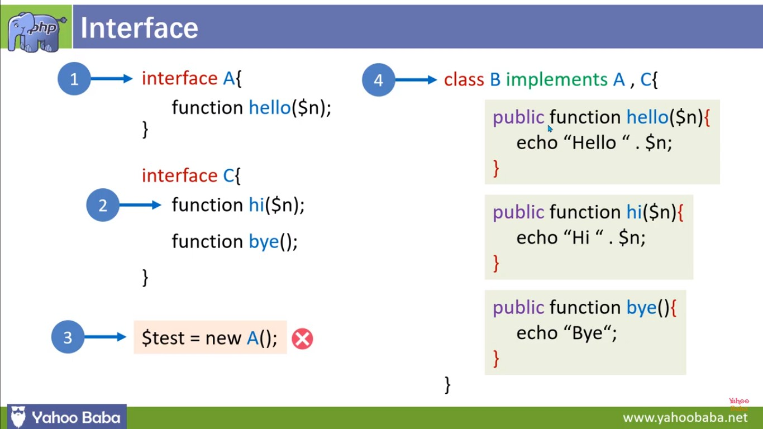

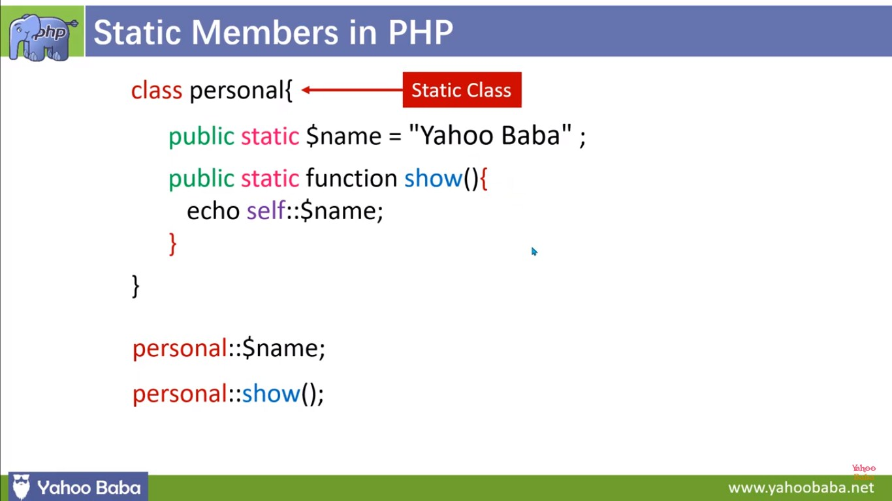

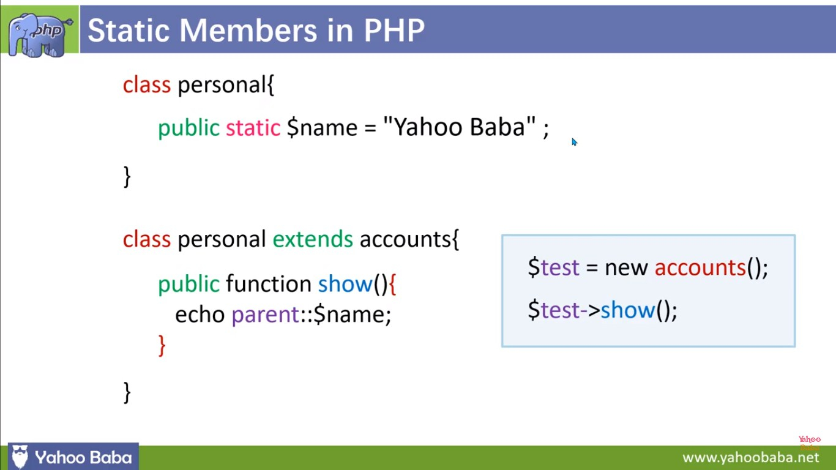

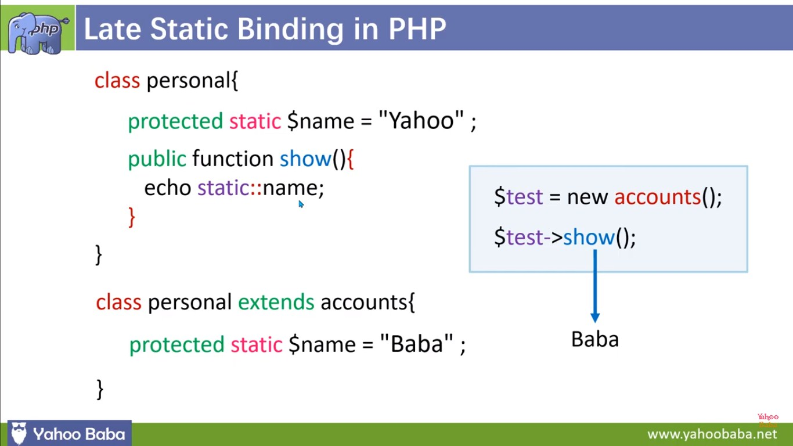

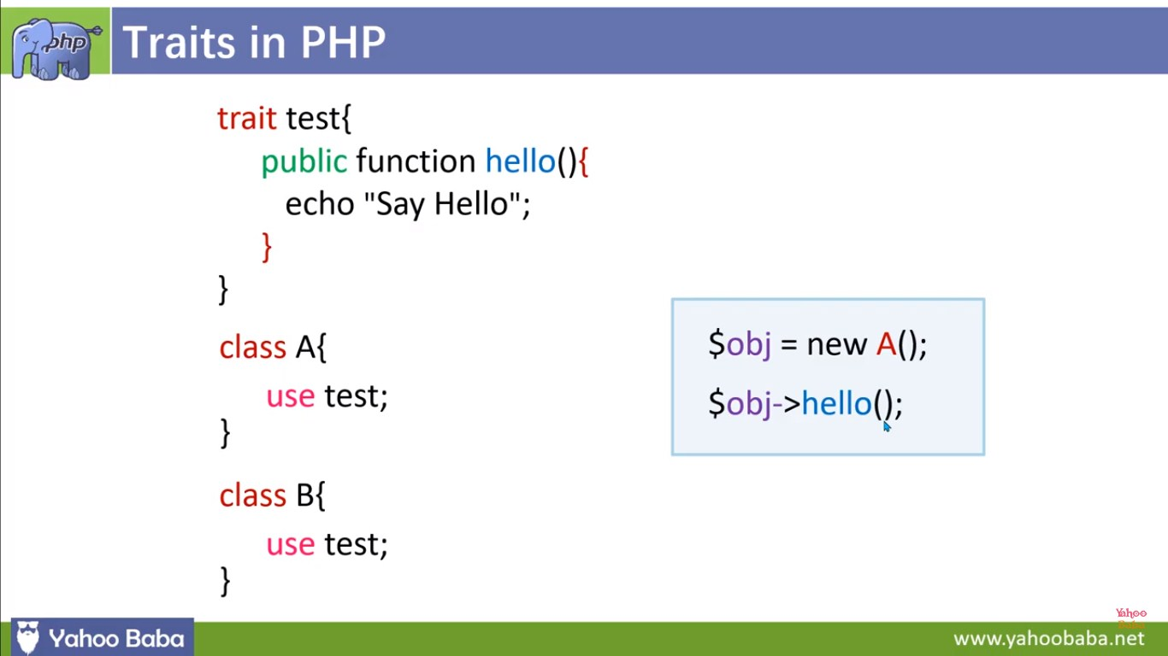

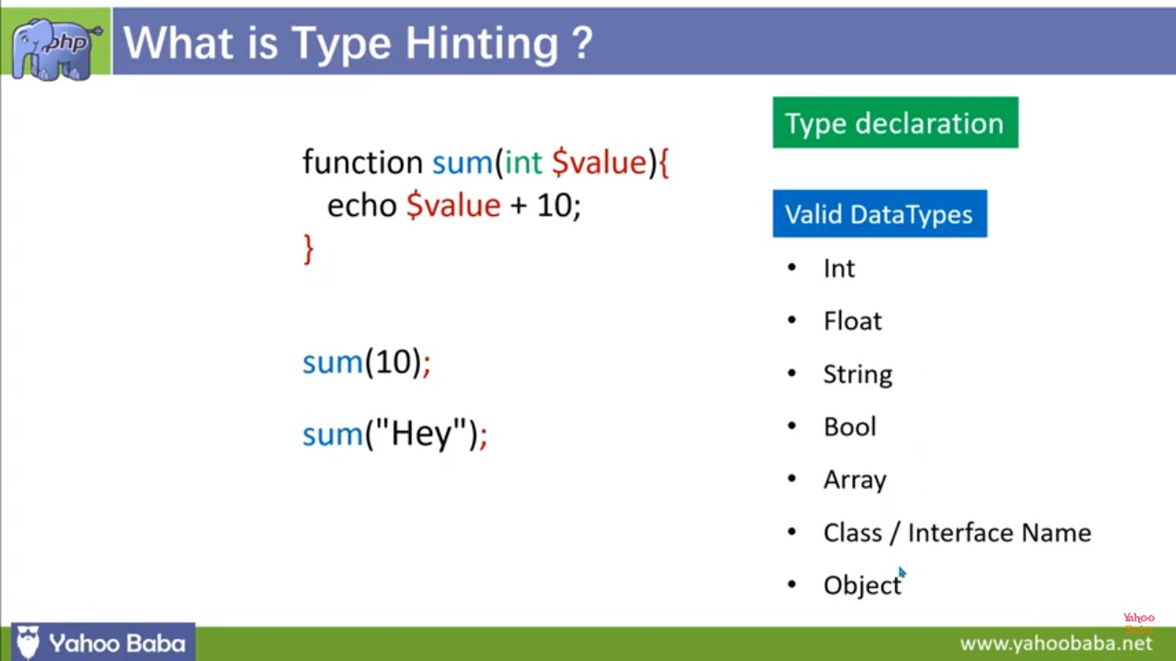

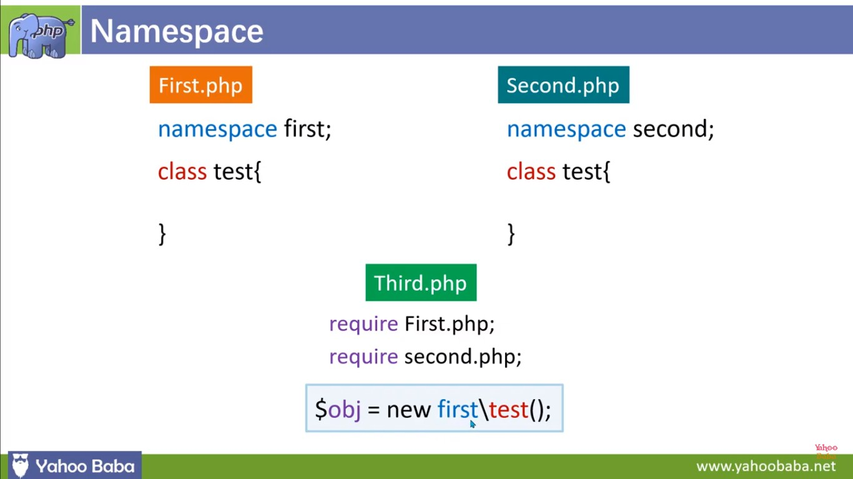

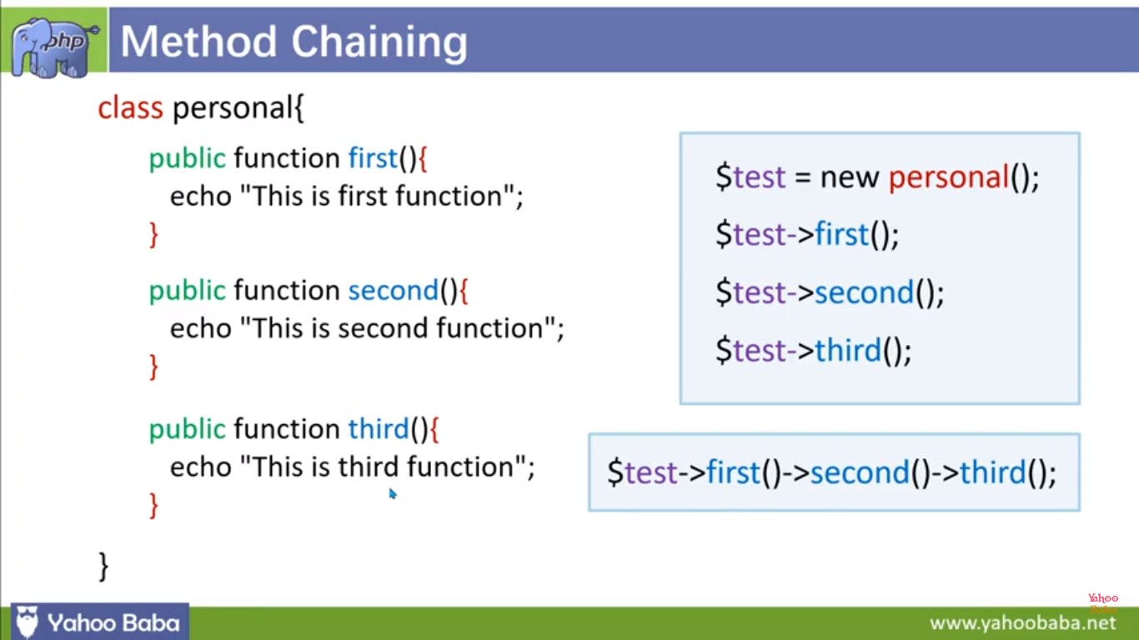

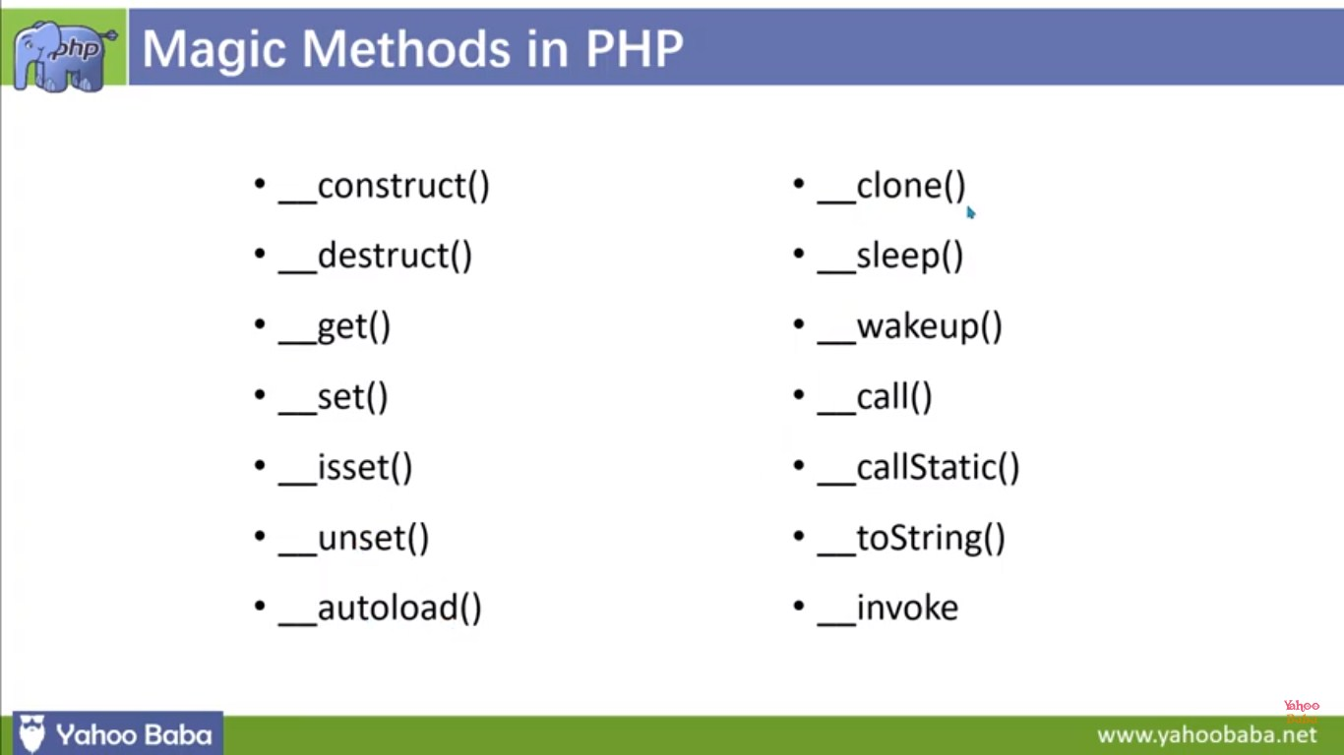

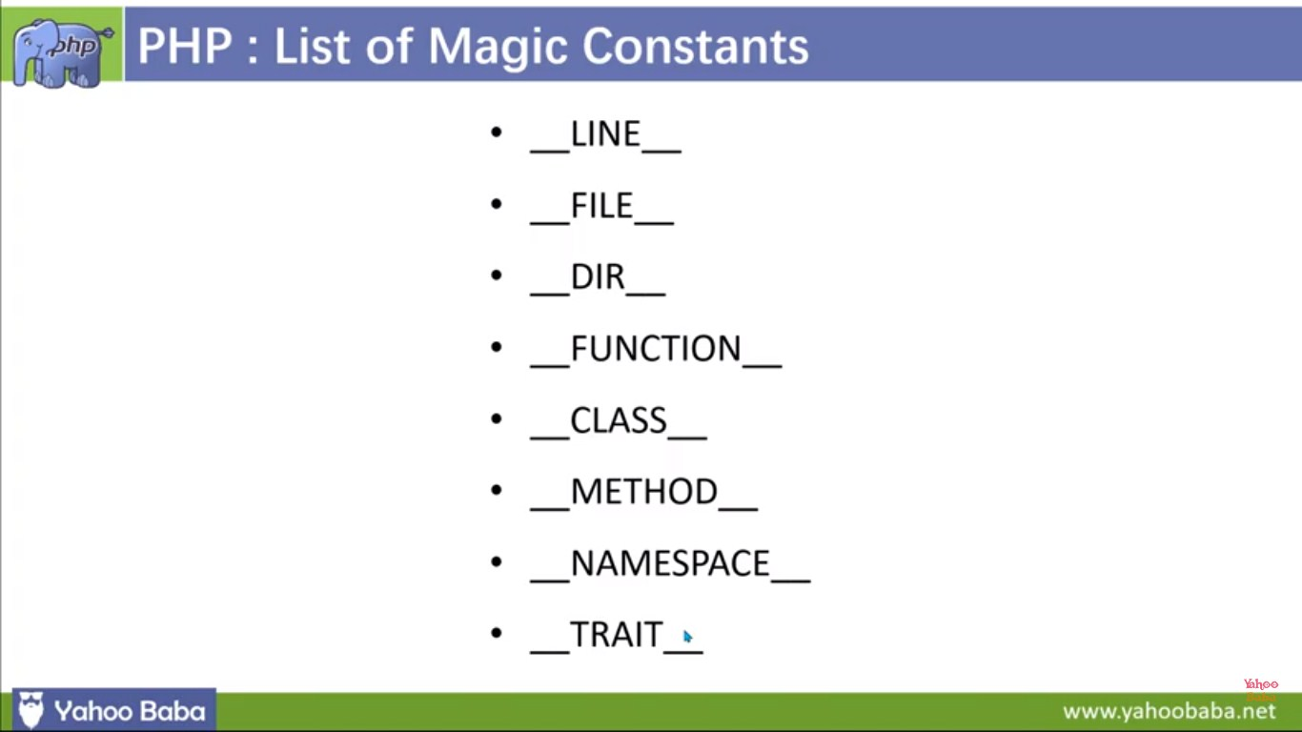

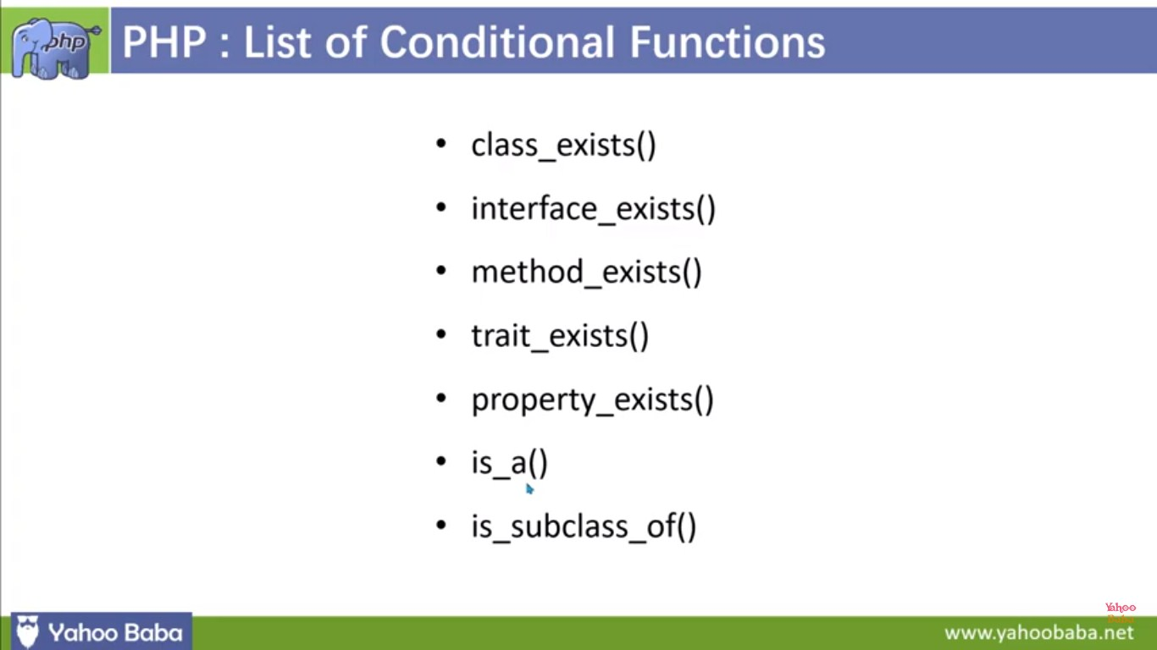

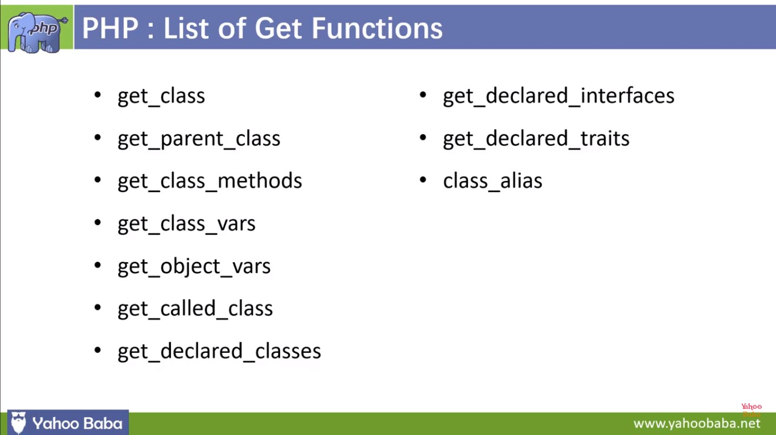

**Magic Method**

**<?php**

**class UserProfile {**

**private $data = [];**

**public function \_\_construct($name, $email) {**

**$this->data['name'] = $name;**

**$this->data['email'] = $email;**

**}**

**public function \_\_get($property) {**

**if (array\_key\_exists($property, $this->data)) {**

**return $this->data[$property];**

**}**

**return null;**

**}**

**public function \_\_set($property, $value) {**

**$this->data[$property] = $value;**

**}**

**public function \_\_toString() {**

**return "Name: {$this->data['name']}, Email: {$this->data['email']}";**

**}**

**}**

**// Create an instance of UserProfile**

**$user = new UserProfile("John Doe", "johndoe@example.com");**

**// Access and modify properties using magic methods**

**echo "Name: " . $user->name . "\n"; // \_\_get is called**

**$user->name = "Jane Doe"; // \_\_set is called**

**echo "Updated Name: " . $user->name . "\n";**

**// Convert the object to a string using \_\_toString**

**echo "User Profile: " . $user . "\n";**

**?>**

1.We have a UserProfile class that stores user data in a private $data array.

2.The \_\_construct method is called when an object of the class is created, initializing the name and email properties.

3.The \_\_get method is used to retrieve property values. If a property doesn't exist, it returns null.

4.The \_\_set method allows us to set or modify property values.

5.The \_\_toString method customizes how the object is converted to a string when we use it in a string context, like echo.

**<?php**

**class MagicDemo {**

**private $data = [];**

**public function \_\_construct() {**

**echo "An instance of MagicDemo has been created.\n";**

**}**

**public function \_\_destruct() {**

**echo "An instance of MagicDemo is being destroyed.\n";**

**}**

**public function \_\_get($property) {**

**echo "Getting property '$property': ";**

**if (array\_key\_exists($property, $this->data)) {**

**return $this->data[$property];**

**} else {**

**return "Property does not exist.\n";**

**}**

**}**

**public function \_\_set($property, $value) {**

**echo "Setting property '$property' to '$value'.\n";**

**$this->data[$property] = $value;**

**}**

**public function \_\_isset($property) {**

**echo "Checking if property '$property' is set: ";**

**return isset($this->data[$property]);**

**}**

**public function \_\_unset($property) {**

**echo "Unsetting property '$property'.\n";**

**unset($this->data[$property]);**

**}**

**public function \_\_call($method, $arguments) {**

**echo "Calling method '$method' with arguments: ";**

**print\_r($arguments);**

**}**

**public function \_\_toString() {**

**return "This is a MagicDemo object.";**

**}**

**}**

**// Create an instance of MagicDemo**

**$obj = new MagicDemo();**

**// Access properties using magic \_\_get and \_\_set**

**$obj->name = "John";**

**echo "Name: " . $obj->name . "\n";**

**// Check property existence using \_\_isset**

**echo isset($obj->age) ? "Age is set.\n" : "Age is not set.\n";**

**// Unset property using \_\_unset**

**unset($obj->name);**

**// Call undefined method using \_\_call**

**$obj->doSomething(42, "Hello");**

**// Convert object to string using \_\_toString**

**echo $obj;**

**?>**

**ALL php magic constant uses one program**

1. **\_\_LINE\_\_**: Returns the current line number of the file.
2. **\_\_FILE\_\_**: Returns the full path and filename of the file.
3. **\_\_DIR\_\_**: Returns the directory of the file.
4. **\_\_FUNCTION\_\_**: Returns the name of the current function.
5. **\_\_CLASS\_\_**: Returns the name of the current class.
6. **\_\_METHOD\_\_**: Returns the name of the current class method.
7. **\_\_NAMESPACE\_\_**: Returns the current namespace name

**<?php**

**class MyClass {**

**public function \_\_construct() {**

**echo "Inside " . \_\_METHOD\_\_ . " in " . \_\_CLASS\_\_ . " within namespace " . \_\_NAMESPACE\_\_ . "\n";**

**}**

**public function showFilePath() {**

**echo "Current file: " . \_\_FILE\_\_ . "\n";**

**echo "Current directory: " . \_\_DIR\_\_ . "\n";**

**}**

**}**

**echo "Current line number: " . \_\_LINE\_\_ . "\n";**

**$obj = new MyClass();**

**$obj->showFilePath();**

**?>**

1. **\_\_LINE\_\_** is used to display the current line number.
2. **\_\_FILE\_\_** and **\_\_DIR\_\_** are used within the **showFilePath** method of the **MyClass** class to display the current file and directory.
3. **\_\_METHOD\_\_**, **\_\_CLASS\_\_**, and **\_\_NAMESPACE\_\_** are used within the constructor of the **MyClass** class to display information about the method, class, and namespace.

**<?php**

**namespace MyNamespace;**

**class MyClass {**

**private $property;**

**public function \_\_construct($value) {**

**$this->property = $value;**

**}**

**public function displayInfo() {**

**echo "Inside " . \_\_METHOD\_\_ . " in " . \_\_CLASS\_\_ . " within namespace " . \_\_NAMESPACE\_\_ . "\n";**

**}**

**public function showFilePath() {**

**echo "Current file: " . \_\_FILE\_\_ . "\n";**

**echo "Current directory: " . \_\_DIR\_\_ . "\n";**

**}**

**public function getProperty() {**

**return $this->property;**

**}**

**}**

**// Use \_\_LINE\_\_ to display the current line number**

**echo "Current line number: " . \_\_LINE\_\_ . "\n";**

**// Create an instance of MyClass and use various magic constants**

**$obj = new MyClass(42);**

**$obj->displayInfo();**

**$obj->showFilePath();**

**// Access class property and display it along with magic constants**

**echo "Property value: " . $obj->getProperty() . "\n";**

**?>**

1. **\_\_LINE\_\_** is used to display the current line number.
2. **\_\_METHOD\_\_**, **\_\_CLASS\_\_**, and **\_\_NAMESPACE\_\_** are used within the **MyClass** class to display information about the method, class, and namespace.
3. **\_\_FILE\_\_** and **\_\_DIR\_\_** are used within the **showFilePath** method of the **MyClass** class to display the current file and directory.
4. Magic constants are used to display information within the main part of the script.

**let var const in js program example**

**// Using var**

**function varExample() {**

**var x = 10;**

**if (true) {**

**var x = 20; // This reassigns the same variable x**

**}**

**console.log("Var Example:", x); // Outputs 20**

**}**

**varExample();**

**// Using let**

**function letExample() {**

**let y = 10;**

**if (true) {**

**let y = 20; // This creates a new variable y within the block**

**}**

**console.log("Let Example:", y); // Outputs 10**

**}**

**letExample();**

**// Using const**

**function constExample() {**

**const z = 10;**

**// z = 20; // This will result in an error (assignment to a constant variable)**

**console.log("Const Example:", z);**

**}**

**constExample();**

1.The varExample function uses var to declare a variable x. It reassigns x within an if block, and the modified value is reflected outside the block.

2.The letExample function uses let to declare a variable y. It creates a new variable y within the if block, and the original value remains unchanged outside the block.

3.The constExample function uses const to declare a constant variable z. An attempt to reassign z to a different value would result in an error.

**Calling parent constructors**

**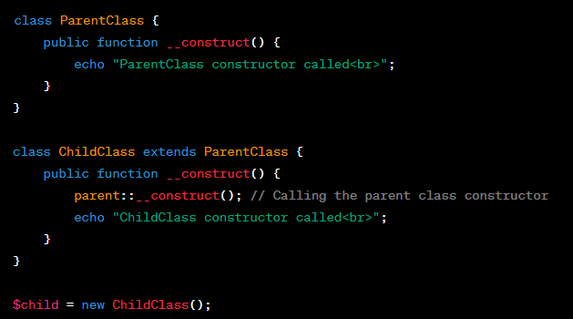**

**class Name {**

**var $\_firstName;**

**var $\_lastName;**

**function Name($first\_name, $last\_name) {**

**$this->\_firstName = $first\_name;**

**$this->\_lastName = $last\_name;**

**}**

**function toString() {**

**return($this->\_lastName .", " .$this->\_firstName);**

**}**

**}**

**class NameSub1 extends Name {**

**var $\_middleInitial;**

**function NameSub1($first\_name, $middle\_initial, $last\_name) {**

**Name::Name($first\_name, $last\_name);**

**$this->\_middleInitial = $middle\_initial;**

**}**

**function toString() {**

**return(Name::toString() . " " . $this->\_middleInitial);**

**}**

**}**

**Calling Parent Constructor**

**class DatabaseConnection {**

**protected $host;**

**protected $username;**

**protected $password;**

**protected $database;**

**protected $connection;**

**public function \_\_construct($host, $username, $password, $database) {**

**$this->host = $host;**

**$this->username = $username;**

**$this->password = $password;**

**$this->database = $database;**

**}**

**public function connect() {**

**// Generic database connection logic**

**$this->connection = new mysqli($this->host, $this->username, $this->password, $this->database);**

**if ($this->connection->connect\_error) {**

**die("Database Connection Error: " . $this->connection->connect\_error);**

**}**

**echo "Connected to the database<br>";**

**}**

**}**

**class MySQLDatabaseConnection extends DatabaseConnection {**

**public function \_\_construct($host, $username, $password, $database) {**

**parent::\_\_construct($host, $username, $password, $database);**

**}**

**// Additional methods and MySQL-specific logic can be added here**

**}**

**// Example usage**

**$mysqlDb = new MySQLDatabaseConnection('localhost', 'mysqluser', 'mysqlpass', 'mysqldb');**

**$mysqlDb->connect();**

**static Keyword**

**<?php**

**class Foo {**

**public static $my\_static = 'foo';**

**public function staticValue() {**

**return self::$my\_static;**

**}**

**}**

**print Foo::$my\_static . "\n";**

**$foo = new Foo();**

**print $foo->staticValue() . "\n";**

**?>**

**late static binding**

**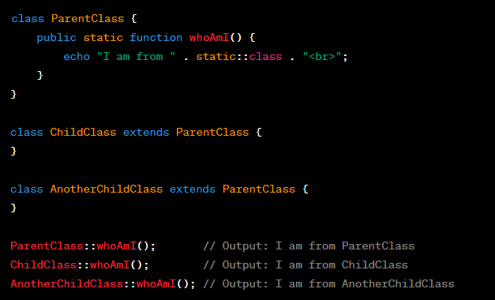**

**Realworld example**

**class Shape {**

**protected $area;**

**public function getArea() {**

**return $this->area;**

**}**

**public static function create($type, $params) {**

**switch ($type) {**

**case 'circle':**

**return Circle::createCircle($params);**

**case 'rectangle':**

**return Rectangle::createRectangle($params);**

**default:**

**throw new InvalidArgumentException("Invalid shape type: $type");**

**}**

**}**

**}**

**class Circle extends Shape {**

**protected $radius;**

**public function \_\_construct($radius) {**

**$this->radius = $radius;**

**$this->area = $this->calculateArea();**

**}**

**public function calculateArea() {**

**return pi() \* $this->radius \* $this->radius;**

**}**

**public static function createCircle($params) {**

**return new static($params['radius']);**

**}**

**}**

**class Rectangle extends Shape {**

**protected $width;**

**protected $height;**

**public function \_\_construct($width, $height) {**

**$this->width = $width;**

**$this->height = $height;**

**$this->area = $this->calculateArea();**

**}**

**public function calculateArea() {**

**return $this->width \* $this->height;**

**}**

**public static function createRectangle($params) {**

**return new static($params['width'], $params['height']);**

**}**

**}**

**// Create a circle and a rectangle using the factory method**

**$circle = Shape::create('circle', ['radius' => 5]);**

**$rectangle = Shape::create('rectangle', ['width' => 4, 'height' => 6]);**

**// Display the areas of the shapes**

**echo "Circle Area: " . $circle->getArea() . "<br>";**

**echo "Rectangle Area: " . $rectangle->getArea() . "<br>";**

**parent Keword**

**class ParentClass {**

**protected $property = "I am a property in the parent class";**

**public function printProperty() {**

**echo $this->property . "<br>";**

**}**

**}**

**class ChildClass extends ParentClass {**

**protected $property = "I am a property in the child class";**

**public function printParentProperty() {**

**// Access the parent class property using the parent keyword**

**echo parent::property . "<br>";**

**// Call the parent class method using the parent keyword**

**parent::printProperty();**

**}**

**}**

**$child = new ChildClass();**

**$child->printParentProperty();**

**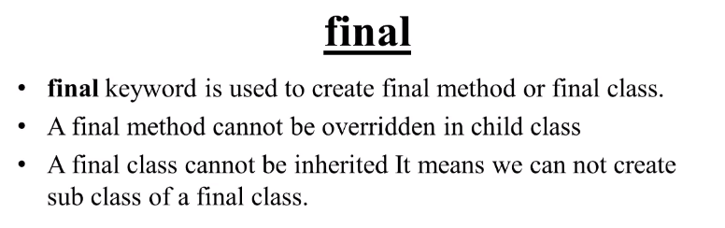**

**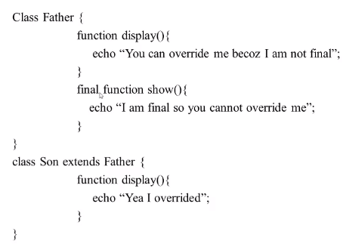**

**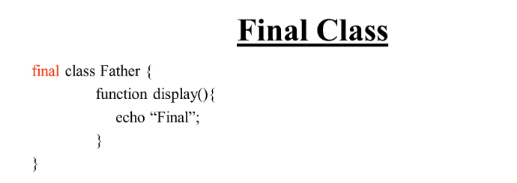**

**Final Keword (method)**

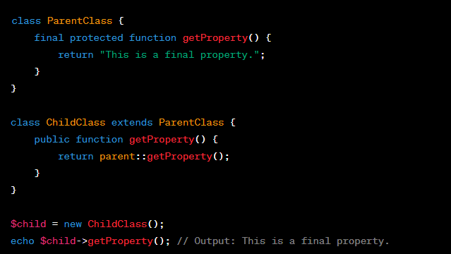

**Final Keword (class)**

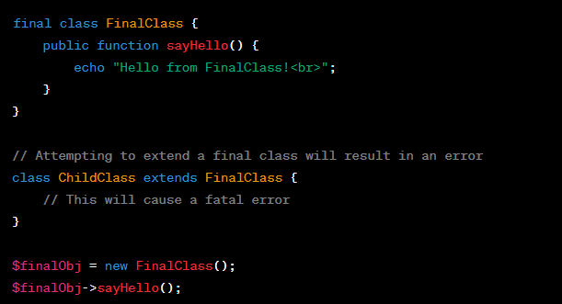

**Abstract class and method**

**// Abstract class for PaymentGateway**

**abstract class PaymentGateway {**

**protected $apiKey;**

**public function \_\_construct($apiKey) {**

**$this->apiKey = $apiKey;**

**}**

**// Abstract method for processing payment**

**abstract public function processPayment($amount);**

**}**

**// Concrete class for PayPal payment gateway**

**class PayPalGateway extends PaymentGateway {**

**public function processPayment($amount) {**

**// Implement the PayPal-specific payment processing logic here**

**// Use $this->apiKey to authenticate with PayPal API**

**// Process the payment and return the result**

**echo "Processing payment of $amount USD using PayPal.<br>";**

**}**

**}**

**// Concrete class for Stripe payment gateway**

**class StripeGateway extends PaymentGateway {**

**public function processPayment($amount) {**

**// Implement the Stripe-specific payment processing logic here**

**// Use $this->apiKey to authenticate with Stripe API**

**// Process the payment and return the result**

**echo "Processing payment of $amount USD using Stripe.<br>";**

**}**

**}**

**// Usage**

**$paypalGateway = new PayPalGateway('your\_paypal\_api\_key');**

**$stripeGateway = new StripeGateway('your\_stripe\_api\_key');**

**$paypalGateway->processPayment(100);**

**$stripeGateway->processPayment(75);**

**Other example**

**abstract class PaymentGateway {**

**abstract public function processPayment($amount);**

**}**

**class PayPalGateway extends PaymentGateway {**

**public function processPayment($amount) {**

**// Process payment using PayPal API**

**echo "Processing payment of $amount via PayPal.<br>";**

**}**

**}**

**class StripeGateway extends PaymentGateway {**

**public function processPayment($amount) {**

**// Process payment using Stripe API**

**echo "Processing payment of $amount via Stripe.<br>";**

**}**

**}**

**// Example usage**

**$paypalGateway = new PayPalGateway();**

**$paypalGateway->processPayment(100);**

**$stripeGateway = new StripeGateway();**

**$stripeGateway->processPayment(150);**

**Interface Example**

**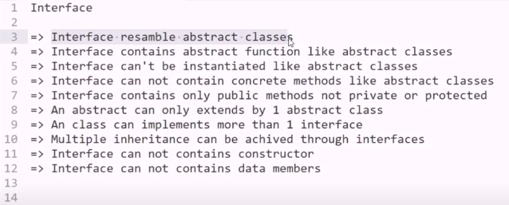**

**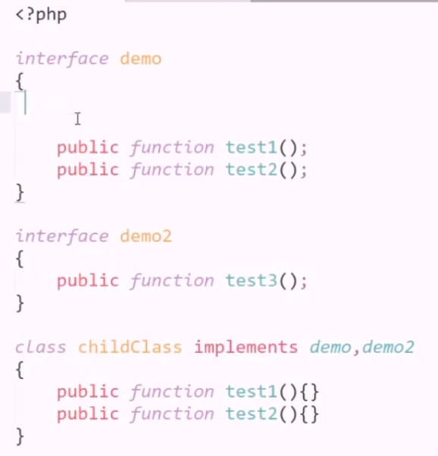**

**interface DatabaseInterface {**

**public function connect($host, $username, $password, $database);**

**public function query($sql);**

**public function close();**

**}**

**class MySQLDatabase implements DatabaseInterface {**

**private $connection;**

**public function connect($host, $username, $password, $database) {**

**// Implement the connection logic for MySQL**

**$this->connection = mysqli\_connect($host, $username, $password, $database);**

**if (!$this->connection) {**

**die("MySQL Connection Error: " . mysqli\_connect\_error());**

**}**

**}**

**public function query($sql) {**

**// Implement the query execution logic for MySQL**

**$result = mysqli\_query($this->connection, $sql);**

**return $result;**

**}**

**public function close() {**

**// Implement the connection closing logic for MySQL**

**mysqli\_close($this->connection);**

**}**

**}**

**class PostgreSQLDatabase implements DatabaseInterface {**

**private $connection;**

**public function connect($host, $username, $password, $database) {**

**// Implement the connection logic for PostgreSQL**

**$this->connection = pg\_connect("host=$host dbname=$database user=$username password=$password");**

**if (!$this->connection) {**

**die("PostgreSQL Connection Error: " . pg\_last\_error());**

**}**

**}**

**public function query($sql) {**

**// Implement the query execution logic for PostgreSQL**

**$result = pg\_query($this->connection, $sql);**

**return $result;**

**}**

**public function close() {**

**// Implement the connection closing logic for PostgreSQL**

**pg\_close($this->connection);**

**}**

**}**

**// Example usage**

**$mysqlDB = new MySQLDatabase();**

**$mysqlDB->connect('localhost', 'user', 'password', 'mydb');**

**$result = $mysqlDB->query('SELECT \* FROM mytable');**

**$mysqlDB->close();**

**$postgresDB = new PostgreSQLDatabase();**

**$postgresDB->connect('localhost', 'user', 'password', 'mydb');**

**$result = $postgresDB->query('SELECT \* FROM mytable');**

**$postgresDB->close();**

**Another Example Interface**

**interface ContentElement {**

**public function render();**

**public function getMetadata();**

**}**

**class Article implements ContentElement {**

**private $title;**

**private $content;**

**public function \_\_construct($title, $content) {**

**$this->title = $title;**

**$this->content = $content;**

**}**

**public function render() {**

**// Implement rendering logic for an article**

**return "<h1>{$this->title}</h1><p>{$this->content}</p>";**

**}**

**public function getMetadata() {**

**// Implement metadata retrieval logic for an article**

**return "Title: {$this->title}";**

**}**

**}**

**class Image implements ContentElement {**

**private $src;**

**private $alt;**

**public function \_\_construct($src, $alt) {**

**$this->src = $src;**

**$this->alt = $alt;**

**}**

**public function render() {**

**// Implement rendering logic for an image**

**return "<img src='{$this->src}' alt='{$this->alt}'>";**

**}**

**public function getMetadata() {**

**// Implement metadata retrieval logic for an image**

**return "Alt Text: {$this->alt}";**

**}**

**}**

**// Example usage**

**$article = new Article("Sample Article", "This is a sample article content.");**

**$image = new Image("image.jpg", "Sample Image Alt Text");**

**echo $article->render();**

**echo $article->getMetadata();**

**echo $image->render();**

**echo $image->getMetadata();**

**PHP interface example code in details in**

In PHP, an interface is a contract that defines a set of methods a class must implement. Interfaces allow you to define a common set of methods that multiple classes can adhere to. Here's an example of a PHP interface along with a class that implements it:

**<?php**

**// Define an interface**

**interface Shape {**

**public function getArea();**

**public function getPerimeter();**

**}**

**// Create a class that implements the interface**

**class Circle implements Shape {**

**private $radius;**

**public function \_\_construct($radius) {**

**$this->radius = $radius;**

**}**

**public function getArea() {**

**return pi() \* pow($this->radius, 2);**

**}**

**public function getPerimeter() {**

**return 2 \* pi() \* $this->radius;**

**}**

**}**

**// Create another class that implements the interface**

**class Rectangle implements Shape {**

**private $width;**

**private $height;**

**public function \_\_construct($width, $height) {**

**$this->width = $width;**

**$this->height = $height;**

**}**

**public function getArea() {**

**return $this->width \* $this->height;**

**}**

**public function getPerimeter() {**

**return 2 \* ($this->width + $this->height);**

**}**

**}**

**// Create instances of the classes and use the interface methods**

**$circle = new Circle(5);**

**echo "Circle Area: " . $circle->getArea() . "\n";**

**echo "Circle Perimeter: " . $circle->getPerimeter() . "\n";**

**$rectangle = new Rectangle(4, 6);**

**echo "Rectangle Area: " . $rectangle->getArea() . "\n";**

**echo "Rectangle Perimeter: " . $rectangle->getPerimeter() . "\n";**

**?>**

**Overloading in php**

**class Calculator {**

**public function calculate($a, $b = null, $c = null) {**

**if ($c !== null) {**

**// Three arguments provided, perform a three-operand calculation**

**return $a + $b + $c;**

**} elseif ($b !== null) {**

**// Two arguments provided, perform a two-operand calculation**

**return $a + $b;**

**} else {**

**// Only one argument provided, return the argument itself**

**return $a;**

**}**

**}**

**}**

**$calculator = new Calculator();**

**// Example usages of method "calculate"**

**$result1 = $calculator->calculate(5);           // Returns 5**

**$result2 = $calculator->calculate(5, 3);        // Returns 8**

**$result3 = $calculator->calculate(5, 3, 2);     // Returns 10**

**echo "Result 1: $result1<br>";**

**echo "Result 2: $result2<br>";**

**echo "Result 3: $result3<br>";**

**Another eample**

**class Database {**

**private $connection;**

**public function \_\_construct($host, $username, $password, $database) {**

**// Establish a database connection (you would use your preferred database extension)**

**$this->connection = new mysqli($host, $username, $password, $database);**

**if ($this->connection->connect\_error) {**

**die("Database Connection Error: " . $this->connection->connect\_error);**

**}**

**}**

**public function query($sql, $operation = 'SELECT', $params = []) {**

**switch ($operation) {**

**case 'SELECT':**

**return $this->selectQuery($sql, $params);**

**case 'INSERT':**

**return $this->insertQuery($sql, $params);**

**case 'UPDATE':**

**return $this->updateQuery($sql, $params);**

**default:**

**throw new InvalidArgumentException("Unsupported database operation: $operation");**

**}**

**}**

**private function selectQuery($sql, $params) {**

**// Implement SELECT query logic with prepared statement**

**// Execute the query, bind parameters, fetch results, etc.**

**return "SELECT result for query: $sql";**

**}**

**private function insertQuery($sql, $params) {**

**// Implement INSERT query logic with prepared statement**

**// Execute the query, bind parameters, handle insert IDs, etc.**

**return "INSERT result for query: $sql";**

**}**

**private function updateQuery($sql, $params) {**

**// Implement UPDATE query logic with prepared statement**

**// Execute the query, bind parameters, handle affected rows, etc.**

**return "UPDATE result for query: $sql";**

**}**

**public function close() {**

**// Close the database connection**

**$this->connection->close();**

**}**

**}**

**// Example usage**

**$db = new Database('localhost', 'username', 'password', 'mydb');**

**$selectResult = $db->query('SELECT \* FROM users WHERE id = ?', 'SELECT', [1]);**

**$insertResult = $db->query('INSERT INTO orders (product, quantity) VALUES (?, ?)', 'INSERT', ['Widget', 5]);**

**$updateResult = $db->query('UPDATE products SET price = ? WHERE id = ?', 'UPDATE', [19.99, 123]);**

**$db->close();**

**echo $selectResult . "<br>";**

**echo $insertResult . "<br>";**

**echo $updateResult . "<br>";**

**Another example**

**class Calculator {**

**public function calculate($operation, ...$operands) {**

**switch ($operation) {**

**case 'add':**

**return $this->add(...$operands);**

**case 'subtract':**

**return $this->subtract(...$operands);**

**case 'multiply':**

**return $this->multiply(...$operands);**

**default:**

**throw new InvalidArgumentException("Unsupported operation: $operation");**

**}**

**}**

**private function add($a, $b) {**

**return $a + $b;**

**}**

**private function subtract($a, $b) {**

**return $a - $b;**

**}**

**private function multiply($a, $b) {**

**return $a \* $b;**

**}**

**}**

**$calculator = new Calculator();**

**// Example usages**

**$result1 = $calculator->calculate('add', 5, 3);**

**$result2 = $calculator->calculate('subtract', 10, 2);**

**$result3 = $calculator->calculate('multiply', 4, 6);**

**echo "Addition result: $result1<br>";**

**echo "Subtraction result: $result2<br>";**

**echo "Multiplication result: $result3<br>";**

**Overriding example**

**class Content {**

**protected $title;**

**protected $content;**

**public function \_\_construct($title, $content) {**

**$this->title = $title;**

**$this->content = $content;**

**}**

**public function display() {**

**// Generic content display**

**echo "<h2>{$this->title}</h2>";**

**echo "<p>{$this->content}</p>";**

**}**

**}**

**class Article extends Content {**

**private $author;**

**public function \_\_construct($title, $content, $author) {**

**parent::\_\_construct($title, $content);**

**$this->author = $author;**

**}**

**public function display() {**

**// Display article-specific content**

**echo "<h2>{$this->title}</h2>";**

**echo "<p>{$this->content}</p>";**

**echo "<p>Author: {$this->author}</p>";**

**}**

**}**

**class Image extends Content {**

**private $imagePath;**

**public function \_\_construct($title, $content, $imagePath) {**

**parent::\_\_construct($title, $content);**

**$this->imagePath = $imagePath;**

**}**

**public function display() {**

**// Display image-specific content**

**echo "<h2>{$this->title}</h2>";**

**echo "<img src='{$this->imagePath}' alt='{$this->title}'><br>";**

**echo "<p>{$this->content}</p>";**

**}**

**}**

**// Example usage**

**$article = new Article("Sample Article", "This is a sample article content.", "John Doe");**

**$image = new Image("Sample Image", "This is a sample image description.", "image.jpg");**

**$article->display();**

**$image->display();**

**Another Example**

**class DatabaseConnection {**

**protected $host;**

**protected $username;**

**protected $password;**

**protected $database;**

**public function \_\_construct($host, $username, $password, $database) {**

**$this->host = $host;**

**$this->username = $username;**

**$this->password = $password;**

**$this->database = $database;**

**}**

**public function connect() {**

**// Generic database connection logic**

**$this->connection = new mysqli($this->host, $this->username, $this->password, $this->database);**

**if ($this->connection->connect\_error) {**

**die("Database Connection Error: " . $this->connection->connect\_error);**

**}**

**echo "Connected to the database using generic driver<br>";**

**}**

**}**

**class MySQLDatabaseConnection extends DatabaseConnection {**

**public function connect() {**

**// MySQL-specific database connection logic**

**parent::connect(); // Call the parent class's connect method first**

**echo "Connected to the MySQL database using MySQLi driver<br>";**

**}**

**}**

**// Example usage**

**$mysqlDb = new MySQLDatabaseConnection('localhost', 'mysqluser', 'mysqlpass', 'mysqldb');**

**$mysqlDb->connect();**

**Overriding very sample example**

**class Animal {**

**public function speak() {**

**echo "Animal speaks!";**

**}**

**}**

**class Dog extends Animal {**

**public function speak() {**

**echo "Dog barks!";**

**}**

**}**

**$animal = new Animal();**

**$dog = new Dog();**

**$animal->speak(); // Output: Animal speaks!**

**$dog->speak();    // Output: Dog barks!**

**Error handling in php**

**// Define a custom error handler function**

**function customErrorHandler($errno, $errstr, $errfile, $errline) {**

**echo "Custom Error Handler: [$errno] $errstr\n";**

**echo "Error on line $errline in $errfile\n";**

**}**

**// Set the custom error handler**

**set\_error\_handler("customErrorHandler");**

**try {**

**// Simulate a division by zero error**

**$result = 10 / 0;**

**} catch (Exception $e) {**

**// This block will not be executed for PHP errors, only for exceptions**

**echo "Caught Exception: " . $e->getMessage() . "\n";**

**} finally {**

**// This block will always be executed, whether there was an error or not**

**echo "Finally block executed\n";**

**}**

**// Attempt to open a non-existent file**

**$file = fopen("nonexistent.txt", "r");**

**if ($file === false) {**

**echo "Error: Failed to open the file.\n";**

**}**

**// Trigger a user-defined error**

**trigger\_error("This is a custom error message.", E\_USER\_WARNING);**

**// Attempt to call a non-existent function**

**nonExistentFunction();**

**// Restore the default error handler**

**restore\_error\_handler();**

**Error handling example**

**class DatabaseConnection {**

**protected $host;**

**protected $username;**

**protected $password;**

**protected $database;**

**protected $connection;**

**public function \_\_construct($host, $username, $password, $database) {**

**$this->host = $host;**

**$this->username = $username;**

**$this->password = $password;**

**$this->database = $database;**

**// Attempt to establish a database connection**

**$this->connect();**

**}**

**private function connect() {**

**// Establish the database connection**

**$this->connection = new mysqli($this->host, $this->username, $this->password, $this->database);**

**// Check for connection errors**

**if ($this->connection->connect\_error) {**

**throw new Exception("Database Connection Error: " . $this->connection->connect\_error);**

**}**

**}**

**public function query($sql) {**

**// Perform a database query**

**$result = $this->connection->query($sql);**

**// Check for query errors**

**if ($result === false) {**

**throw new Exception("Database Query Error: " . $this->connection->error);**

**}**

**return $result;**

**}**

**public function close() {**

**// Close the database connection**

**$this->connection->close();**

**}**

**}**

**// Example usage with error handling**

**try {**

**$db = new DatabaseConnection('localhost', 'username', 'password', 'mydb');**

**// Example query with an error (table doesn't exist)**

**$result = $db->query('SELECT \* FROM non\_existing\_table');**

**// Close the database connection**

**$db->close();**

**} catch (Exception $e) {**

**// Handle database-related exceptions**

**echo "Caught exception: " . $e->getMessage();**

**}**

**Another Example**

**class DatabaseConnection {**

**protected $host;**

**protected $username;**

**protected $password;**

**protected $database;**

**protected $connection;**

**public function \_\_construct($host, $username, $password, $database) {**

**$this->host = $host;**

**$this->username = $username;**

**$this->password = $password;**

**$this->database = $database;**

**// Attempt to establish a database connection**

**$this->connect();**

**}**

**private function connect() {**

**// Establish the database connection**

**$this->connection = new mysqli($this->host, $this->username, $this->password, $this->database);**

**// Check for connection errors**

**if ($this->connection->connect\_error) {**

**throw new Exception("Database Connection Error: " . $this->connection->connect\_error);**

**}**

**}**

**public function executeQuery($sql) {**

**// Execute a database query and return the result**

**return $this->connection->query($sql);**

**}**

**public function getLastInsertId() {**

**// Get the last auto-generated ID from an INSERT query**

**return $this->connection->insert\_id;**

**}**

**public function close() {**

**// Close the database connection**

**$this->connection->close();**

**}**

**}**

**class User {**

**private $db;**

**public function \_\_construct(DatabaseConnection $db) {**

**$this->db = $db;**

**}**

**public function addUser($username, $email, $password) {**

**$username = $this->db->connection->real\_escape\_string($username);**

**$email = $this->db->connection->real\_escape\_string($email);**

**$password = $this->db->connection->real\_escape\_string($password);**

**$sql = "INSERT INTO users (username, email, password) VALUES ('$username', '$email', '$password')";**

**$result = $this->db->executeQuery($sql);**

**if ($result) {**

**echo "User added successfully with ID: " . $this->db->getLastInsertId();**

**} else {**

**throw new Exception("Error adding user: " . $this->db->connection->error);**

**}**

**}**

**}**

**// Example usage**

**try {**

**$db = new DatabaseConnection('localhost', 'username', 'password', 'mydb');**

**$user = new User($db);**

**$user->addUser('john\_doe', 'john@example.com', 'password123');**

**// Close the database connection**

**$db->close();**

**} catch (Exception $e) {**

**// Handle exceptions, e.g., display an error message**

**echo "Caught exception: " . $e->getMessage();**

**}**

**Exeception handling in php**

**class DatabaseConnectionException extends Exception {**

**public function errorMessage() {**

**return "Database Connection Error: " . $this->getMessage();**

**}**

**}**

**class Database {**

**private $connection;**

**public function \_\_construct($host, $username, $password, $database) {**

**try {**

**$this->connection = new mysqli($host, $username, $password, $database);**

**if ($this->connection->connect\_error) {**

**throw new DatabaseConnectionException($this->connection->connect\_error);**

**}**

**} catch (DatabaseConnectionException $e) {**

**// Handle the exception**

**die($e->errorMessage());**

**}**

**}**

**public function query($sql) {**

**try {**

**if (!$this->connection) {**

**throw new DatabaseConnectionException("No database connection.");**

**}**

**$result = $this->connection->query($sql);**

**if ($result === false) {**

**throw new Exception("Database query error: " . $this->connection->error);**

**}**

**return $result;**

**} catch (Exception $e) {**

**// Handle the exception**

**die("Error: " . $e->getMessage());**

**}**

**}**

**public function close() {**

**if ($this->connection) {**

**$this->connection->close();**

**}**

**}**

**}**

**// Example usage**

**try {**

**$db = new Database("localhost", "username", "password", "mydb");**

**$result = $db->query("SELECT \* FROM non\_existing\_table");**

**$db->close();**

**} catch (Exception $e) {**

**// Handle any exception thrown during database connection or query**

**echo "Caught exception: " . $e->getMessage();**

**}**

**Indexing in Database**

1. **Fast Data Retrieval:** Indexes speed up data retrieval operations, such as SELECT queries, by reducing the number of rows that need to be scanned in a table. Instead of scanning the entire table, the database engine uses the index to locate the relevant rows more efficiently.
2. **Structure:** An index is a separate data structure that contains a copy of selected columns from a table, along with a reference to the corresponding rows in the table. This structure allows for quick lookups.
3. **Columns Selection:** You can create indexes on one or more columns of a table. Commonly indexed columns include primary keys, foreign keys, frequently searched columns, and columns used in JOIN and WHERE clauses.
4. **Types of Indexes:** Various types of indexes exist, including primary indexes, secondary indexes, clustered indexes, non-clustered indexes, and full-text indexes. Each type has specific use cases and characteristics.
   * **Primary Index:** A primary index uniquely identifies each row in a table and enforces data integrity. There can be only one primary index per table.
   * **Secondary Index:** A secondary index is created on columns other than the primary key. It helps optimize search queries.
   * **Clustered Index:** In some database systems (e.g., SQL Server), a table can have only one clustered index, which determines the physical order of rows in the table. It is usually created on the primary key or another unique column.
   * **Non-Clustered Index:** A non-clustered index provides an alternative path to access data rows and includes a pointer to the actual data row.
5. **Trade-offs:** While indexing can significantly improve read performance, it comes with trade-offs. Indexes consume storage space and can slow down write operations (INSERT, UPDATE, DELETE) because each modification must also update the corresponding index entries. Therefore, it's important to strike a balance between read and write performance.
6. **Maintenance:** Indexes require regular maintenance to keep them efficient. Database systems may automatically update and reorganize indexes, but it's essential to monitor index performance and occasionally rebuild or defragment them if needed.
7. **Query Optimization:** The query optimizer in a database management system uses indexes to determine the most efficient execution plan for queries. Properly designed indexes can lead to faster query execution.

In summary, indexing is a crucial database optimization technique that improves the speed and efficiency of data retrieval operations while carefully considering the trade-offs associated with storage and write performance. Effective indexing is a fundamental aspect of database design and query performance tuning.

**Indexing Procedure**

Indexing in MySQL, when combined with PHP, can significantly improve the performance of your database-driven web applications. Here are the steps to create and utilize indexes effectively with MySQL and PHP:

**Step 1: Design Your Database Schema**

The first step in effective indexing is to design your database schema correctly. Identify the columns that are frequently used in WHERE clauses, JOIN operations, and ORDER BY clauses in your SQL queries. These are the columns that should be considered for indexing.

**Step 2: Choose the Right Index Types**

MySQL supports various index types, including PRIMARY KEY, UNIQUE, INDEX, and FULLTEXT. Choose the appropriate index type based on your data and query requirements. Common choices include:

* **PRIMARY KEY:** Used for uniquely identifying rows in a table.
* **INDEX:** Used for non-unique indexing of columns.
* **UNIQUE:** Ensures that all values in the indexed column(s) are unique.
* **FULLTEXT:** Used for full-text searches in text-based columns.

**Step 3: Create Indexes**

You can create indexes using SQL statements in MySQL. For example, to create an index on the **email** column of a **users** table:

**CREATE INDEX idx\_email ON users (email);**

Alternatively, you can define indexes when creating tables:

**CREATE TABLE users (**

**id INT PRIMARY KEY,**

**username VARCHAR(255) UNIQUE,**

**email VARCHAR(255) INDEX,**

**-- other columns...**

**);**

**Step 4: Monitor Query Performance**

Once indexes are created, monitor the performance of your SQL queries using the MySQL query analyzer or other performance profiling tools. Identify queries that benefit from indexes and those that need optimization.

**Step 5: Utilize EXPLAIN**

Use the **EXPLAIN** statement to analyze query execution plans. For example:

**EXPLAIN SELECT \* FROM users WHERE email = 'user@example.com';**

**EXPLAIN** will provide insight into how MySQL is executing the query and whether it's using indexes efficiently.

**Step 6: Adjust Indexes**

Based on query performance analysis, you may need to adjust your indexes. You might need to add additional indexes, remove redundant indexes, or modify existing indexes.

**Step 7: Regularly Optimize Indexes**

Periodically check the fragmentation and efficiency of your indexes. MySQL provides tools like **OPTIMIZE TABLE** and **ANALYZE TABLE** to maintain and optimize your indexes.

**Step 8: Leverage PHP for Query Optimization**

While most of the index creation and maintenance tasks are performed in MySQL, PHP can also play a role in query optimization. Ensure your PHP code uses parameterized queries to prevent SQL injection and leverages caching mechanisms for frequently used query results.

**Step 9: Test at Scale**

Finally, test your application and database performance at scale to ensure that the indexing strategy remains effective as your data grows and user traffic increases.

Remember that indexing is not a one-size-fits-all solution. The effectiveness of indexes depends on your specific application and query patterns. Regular monitoring and adjustments are essential for maintaining optimal performance.

Top of Form

**Caching**

Caching in a server context refers to the process of storing and reusing previously generated data or responses to reduce the time and resources required to fulfill subsequent requests. Caching is a critical technique for improving the performance and responsiveness of web servers and applications. There are several types of caching that can be implemented on a server:

1. **Page Caching:** Page caching stores entire HTML pages as static files. When a user requests a page that has been cached, the server can serve the cached page directly without processing PHP scripts or querying a database. Popular tools like Varnish and WP Super Cache for WordPress offer page caching capabilities.
2. **Object Caching:** Object caching stores frequently used data objects, such as database query results or API responses, in memory. This reduces the need to repeatedly fetch the same data from slow data sources. Memcached and Redis are commonly used object caching solutions.
3. **Opcode Caching:** Opcode caching stores compiled PHP code in memory so that it can be reused for subsequent PHP script executions. This significantly speeds up the execution of PHP scripts. Popular opcode caching tools include APCu, OPcache (built-in to PHP), and XCache.
4. **CDN (Content Delivery Network) Caching:** CDNs cache static assets like images, stylesheets, and JavaScript files on geographically distributed servers. This reduces the latency and load on your web server and speeds up the delivery of content to users.
5. **Database Query Caching:** Database query caching stores the results of database queries in memory, reducing the need to re-execute the same queries. Many database systems, such as MySQL and PostgreSQL, have built-in query caching features.
6. **Reverse Proxy Caching:** A reverse proxy server like Nginx or Apache can cache responses from your application server. This is often used in combination with load balancing and SSL termination to improve performance and security.
7. **Browser Caching:** In addition to server-side caching, instructing web browsers to cache static assets (e.g., images, CSS, JavaScript) can reduce the need for repeated downloads when users revisit your site.

Implementing caching effectively requires a good understanding of your application's architecture and performance bottlenecks. You'll need to decide what should be cached, how long data should be cached, and which caching technologies are most appropriate for your specific use case. Caching can significantly improve the speed and efficiency of your server but should be used judiciously to avoid serving outdated or stale data to users.

Enabling caching on a server can significantly improve the performance and responsiveness of websites and web applications. Caching reduces the need to regenerate or fetch data for each user request by storing and serving previously generated content. There are several ways to enable caching on a server, and the specific method you choose depends on your server setup and requirements. Here are some common caching techniques and how to enable them:

1. **Browser Caching:**
   * Browser caching instructs web browsers to store static assets (such as images, stylesheets, and JavaScript files) locally on the user's device. This reduces the need to re-download these assets on subsequent visits.
   * To enable browser caching, add cache-control headers to your web server's configuration or within your application code. For Apache, you can use **.htaccess** files, and for Nginx, you can configure it in the server block.

Example (Apache):

**<FilesMatch "\.(jpg|jpeg|png|gif|js|css)$">**

**Header set Cache-Control "max-age=31536000, public"**

**</FilesMatch>**

**Opcode Caching (PHP):**

* Opcode caching stores compiled PHP code in memory to avoid recompilation for each request. This can significantly improve the execution speed of PHP scripts.
* Popular PHP opcode caching tools include APCu, OPcache (included in PHP by default), and XCache. To enable opcode caching, you typically need to install the appropriate extension and configure it in your **php.ini** file.

Example (php.ini for OPcache):

**zend\_extension=opcache.so**

**opcache.enable=1**

1. **Object Caching (PHP and Database):**
   * Object caching stores frequently used data objects, such as database query results or API responses, in memory. This reduces the need to repeatedly fetch the same data from a slow data source.
   * You can use caching libraries like Memcached or Redis for object caching in PHP. Additionally, some database systems have built-in query caching mechanisms.
2. **Content Delivery Network (CDN) Caching:**
   * CDNs cache static assets and deliver them from geographically distributed servers. This reduces latency and load on your web server.
   * To enable CDN caching, sign up for a CDN service, configure your CDN settings, and update your DNS records to point to the CDN.
3. **Page Caching (WordPress and CMS):**
   * Content management systems (CMS) like WordPress often have built-in page caching plugins. Enable and configure these plugins to cache full HTML pages.
   * For WordPress, popular caching plugins include W3 Total Cache and WP Super Cache.
4. **Reverse Proxy Caching (Nginx and Varnish):**
   * Reverse proxy servers like Nginx and Varnish can cache responses from your application server. This is often used in combination with load balancing and SSL termination.
   * Configure reverse proxy caching in your server configuration files.

Remember to test your caching setup thoroughly to ensure that it improves performance without causing issues like serving stale content to users. Additionally, monitor cache performance and adjust settings as needed, especially as your website or application evolves.

**Google login API**

Google Sign-In with PHP using Google API Client Library:

1. **Create a Project in Google Cloud Console:**
   * Go to the [Google Cloud Console](https://console.cloud.google.com/).
   * Create a new project or select an existing one.
   * Enable the "Google+ API" for your project.
2. **Create OAuth 2.0 Credentials:**
   * In the Cloud Console, navigate to "APIs & Services" > "Credentials."
   * Click on "Create Credentials" and choose "OAuth client ID."
   * Select "Web application" as the application type.
   * Configure the authorized JavaScript origins and redirect URIs. For local development, you can use "[http://localhost](http://localhost/)" as the origin.
   * Click "Create" to generate your OAuth client ID and client secret.
3. **Install Google API Client Library for PHP:**
   * You can install the Google API Client Library for PHP using Composer:

**composer require google/apiclient:"^2.0"**

1. **Set Up the PHP Code:**

* Create a PHP file (e.g., **google\_login.php**) and add the following code:

**<?php**

**require\_once 'vendor/autoload.php';**

**$client = new Google\_Client();**

**$client->setClientId('YOUR\_CLIENT\_ID');**

**$client->setClientSecret('YOUR\_CLIENT\_SECRET');**

**$client->setRedirectUri('YOUR\_REDIRECT\_URI');**

**$client->addScope('email');**

**$client->addScope('profile');**

**if (isset($\_GET['code'])) {**

**$token = $client->fetchAccessTokenWithAuthCode($\_GET['code']);**

**$client->setAccessToken($token);**

**$oauth2Service = new Google\_Service\_Oauth2($client);**

**$userInfo = $oauth2Service->userinfo->get();**

**// Now, you can use $userInfo to access user data (e.g., $userInfo->getEmail(), $userInfo->getGivenName()).**

**echo "Welcome, " . $userInfo->getName();**

**} else {**

**$authUrl = $client->createAuthUrl();**

**echo "<a href='$authUrl'>Login with Google</a>";**

**}**

**?>**

**For insert data in MySQL first we have to create a table in data base.**

Here we using 3 file for insert data in MySQL:

CREATE TABLE `employee` (

`userid` int(8) NOT NULL AUTO\_INCREMENT,

`first\_name` varchar(55) NOT NULL,

`last\_name` varchar(55) NOT NULL,

`city\_name` varchar(55) NOT NULL,

`email` varchar(50) NOT NULL,

`datetime` datetime NOT NULL

) ENGINE=InnoDB DEFAULT CHARSET=latin1;

**index.php:**for getting the values from the user

<!DOCTYPE html>

<html>

  <body>

    <form method="post" action="process.php">

        First name:<br>

        <input type="text" name="first\_name">

        <br>

        Last name:<br>

        <input type="text" name="last\_name">

        <br>

        City name:<br>

        <input type="text" name="city\_name">

        <br>

        Email Id:<br>

        <input type="email" name="email">

        <br><br>

        <input type="submit" name="submit" value="submit">

    </form>

  </body>

</html>

**Crud.php:**For connecting data base and function

<?php

    class Crud

    {

        private $servername = "localhost";

        private $username   = "root";

        private $password   = "";

        private $dbname = "oops\_db";

        public $con;

        public $employeeTable = "employee";

        public function \_\_construct()

        {

            try {

                $this->con = new mysqli($this->servername, $this->username, $this->password, $this->dbname);

            } catch (Exception $e) {

                echo $e->getMessage();

            }

        }

        public function save($first\_name, $last\_name, $city\_name, $email, $insertdate)

        {

            $sql = "INSERT INTO $this->employeeTable(first\_name,last\_name,city\_name,email,datetime) VALUES('$first\_name', '$last\_name','$city\_name','$email','$insertdate')";

            $query = $this->con->query($sql);

            if ($query) {

                return true;

            }else{

                return false;

            }

        }

    }

?>

**process.php:A PHP file that process the request**

<?php

include\_once("Crud.php");

$insertdata=new Crud();

if(isset($\_POST['submit']))

{

    $first\_name = $\_POST['first\_name'];

    $last\_name = $\_POST['last\_name'];

    $city\_name = $\_POST['city\_name'];

    $email = $\_POST['email'];

    date\_default\_timezone\_set("Asia/Calcutta");

    $insertdate = date("Y-m-d H:i:s");

    $sql=$insertdata->save($first\_name, $last\_name,$city\_name,$email,$insertdate);

    if($sql)

    {

       echo "Data inserted successfully !";

    }

    else

    {

        echo "Data inserted error !";

    }

}

 ?>

**For retrieve data from MySQL first we have to create a table in data base.**

CREATE TABLE `employee` (

    `userid` int(8) NOT NULL AUTO\_INCREMENT,

    `first\_name` varchar(55) NOT NULL,

    `last\_name` varchar(55) NOT NULL,

    `city\_name` varchar(55) NOT NULL,

    `email` varchar(50) NOT NULL,

    `datetime` datetime NOT NULL

) ENGINE=InnoDB DEFAULT CHARSET=latin1;

crud.php

<?php

    class Crud

    {

        private $servername = "localhost";

        private $username   = "root";

        private $password   = "";

        private $dbname = "oops\_db";

        public $con;

        public $employeeTable = "employee";

        public function \_\_construct()

        {

            try {

                $this->con = new mysqli($this->servername, $this->username, $this->password, $this->dbname);

            } catch (Exception $e) {

                echo $e->getMessage();

            }

        }

        /\* Fetch employee records for show listing \*/

        public function displayRecord()

        {

            $sql = "SELECT \* FROM $this->employeeTable";

            $query = $this->con->query($sql);

            $data = array();

            if ($query->num\_rows > 0) {

                while ($row = $query->fetch\_assoc()) {

                    $data[] = $row;

                }

                return $data;

            }else{

                return false;

            }

        }

    }

?>

view.php

<!DOCTYPE html>

<html lang="en">

<head>

    <title>Bootstrap Example</title>

    <meta charset="utf-8">

    <meta name="viewport" content="width=device-width, initial-scale=1">

    <link rel="stylesheet" href="https://maxcdn.bootstrapcdn.com/bootstrap/4.5.2/css/bootstrap.min.css">

    <script src="https://ajax.googleapis.com/ajax/libs/jquery/3.5.1/jquery.min.js"></script>

    <script src="https://cdnjs.cloudflare.com/ajax/libs/popper.js/1.16.0/umd/popper.min.js"></script>

    <script src="https://maxcdn.bootstrapcdn.com/bootstrap/4.5.2/js/bootstrap.min.js"></script>

</head>

<body>

<?php

include\_once("Crud.php");

$viewdata=new Crud();

$customers = $viewdata->displayRecord();

$output ="";

$output .="<table class='table table-striped table-hover'>

            <thead>

                <tr>

                    <th>Id</th>

                    <th>First Name</th>

                    <th>Last Name</th>

                    <th>City Name</th>

                    <th>Email</th>

                </tr>

            </thead>

            <tbody>";

    foreach ($customers as $customer) {

            $output.="<tr>

                <td>".$customer['userid']."</td>

                <td>".$customer['first\_name']."</td>

                <td>".$customer['last\_name']."</td>

                <td>".$customer['city\_name']."</td>

                <td>".$customer['email']."</td>

            </tr>";

        }

$output .= "</tbody>

</table>";

echo $output;

?>

</body></html>

# PHP oops update data

#### crud.php

<?php

        class Crud

        {

            private $servername = "localhost";

    private $username   = "root";

    private $password   = "";

    private $dbname = "oops\_db";

            public $con;

            public $employeeTable = "employee";

    public function \_\_construct()

    {

    try {

    $this->con = new mysqli($this->servername, $this->username, $this->password, $this->dbname);

    } catch (Exception $e) {

    echo $e->getMessage();

    }

    }

    public function update($userid,$first\_name, $last\_name,$city\_name,$email,$insertdate)

            {

            echo  $sql = "UPDATE $this->employeeTable SET first\_name='$first\_name',last\_name='$last\_name',city\_name='$city\_name',email='$email' where userid=$userid";

                $query = $this->con->query($sql);

    if ($query) {

    return true;

    }else{

    return false;

    }

            }

        }

    ?>

#### update.php

<?php

include\_once("Crud.php");

$userid=$\_GET['userid'];

$viewdata=new Crud();

$employee = $viewdata->displayRecordbyid($userid);

?>

<!DOCTYPE html>

<html>

<body>

<form method="post" action="update\_process.php">

First name:<br>

<input type="text" name="first\_name" value="<?php echo $employee['first\_name'];?>">

<br>

Last name:<br>

<input type="text" name="last\_name" value="<?php echo $employee['last\_name'];?>">

<br>

City name:<br>

<input type="text" name="city\_name" value="<?php echo $employee['city\_name'];?>">

<br>

Email Id:<br>

<input type="email" name="email" value="<?php echo $employee['email'];?>">

<br><br>

<input type="hidden" name="userid" value="<?php echo $employee['userid'];?>">

<input type="submit" name="submit" value="submit">

</form>

</body>

</html>

#### update\_process.php

<?php

include\_once("Crud.php");

$insertdata=new Crud();

if(isset($\_POST['submit']))

{

$userid = $\_POST['userid'];

$first\_name = $\_POST['first\_name'];

$last\_name = $\_POST['last\_name'];

$city\_name = $\_POST['city\_name'];

$email = $\_POST['email'];

date\_default\_timezone\_set("Asia/Calcutta");

$insertdate = date("Y-m-d H:i:s");

$sql=$insertdata->update($userid,$first\_name, $last\_name,$city\_name,$email,$insertdate);

if($sql)

{

echo "Data inserted successfully !";

}

else

{

echo "Data inserted error !";

}

}

?>

#### For delete data from MySQL first we have to create a table in data base.

#### **delete\_process.php:**For Delete process in backend

CREATE TABLE `employee` (

`userid` int(8) NOT NULL AUTO\_INCREMENT,

`first\_name` varchar(55) NOT NULL,

`last\_name` varchar(55) NOT NULL,

`city\_name` varchar(55) NOT NULL,

`email` varchar(50) NOT NULL,

`datetime` datetime NOT NULL

) ENGINE=InnoDB DEFAULT CHARSET=latin1;

#### crud.php

<?php

class Crud

{

private $servername = "localhost";

private $username = "root";

private $password = "";

private $dbname = "oops\_db";

public $con;

public $employeeTable = "employee";

public function \_\_construct()

{

try {

$this->con = new mysqli($this->servername, $this->username, $this->password, $this->dbname);

} catch (Exception $e) {

echo $e->getMessage();

}

}

/\* Fetch employee records for show listing \*/

public function displayRecord()

{

$sql = "SELECT \* FROM $this->employeeTable";

$query = $this->con->query($sql);

$data = array();

if ($query->num\_rows > 0) {

while ($row = $query->fetch\_assoc()) {

$data[] = $row;

}

return $data;

}else{

return false;

}

}

public function deleteRecord($id)

{

$sql = "DELETE from $this->employeeTable where userid=$id";

$query = $this->con->query($sql);

$data = array();

if ($query) {

return true;

}else{

return false;

}

}

}

?>

**\**

#### view.php

<!DOCTYPE html>

<html lang="en">

<head>

<title>Bootstrap Example</title>

<meta charset="utf-8">

<meta name="viewport" content="width=device-width, initial-scale=1">

<link rel="stylesheet" href="https://maxcdn.bootstrapcdn.com/bootstrap/4.5.2/css/bootstrap.min.css">

<script src="https://ajax.googleapis.com/ajax/libs/jquery/3.5.1/jquery.min.js"></script>

<script src="https://cdnjs.cloudflare.com/ajax/libs/popper.js/1.16.0/umd/popper.min.js"></script>

<script src="https://maxcdn.bootstrapcdn.com/bootstrap/4.5.2/js/bootstrap.min.js"></script>

</head>

<body>

<?php

include\_once("Crud.php");

$viewdata=new Crud();

$customers = $viewdata->displayRecord();

$output ="";

$output .="<table class='table table-striped table-hover'>

<thead>

<tr>

<th>Id</th>

<th>First Name</th>

<th>Last Name</th>

<th>City Name</th>

<th>Email</th>

<th>Action</th>

</tr>

</thead>

<tbody>";

foreach ($customers as $customer) {

$output.="<tr>

<td>".$customer['userid']."</td>

<td>".$customer['first\_name']."</td>

<td>".$customer['last\_name']."</td>

<td>".$customer['city\_name']."</td>

<td>".$customer['email']."</td>

<td><a href='delete\_process.php?id=".$customer['userid']."'>Delete</a></td>

</tr>";

}

$output .= "</tbody>

</table>";

echo $output;

?>

</body>

</html>

#### crud.php

#### <?php

include\_once("Crud.php");

$insertdata=new Crud();

$id = $\_GET['id'];

$sql=$insertdata->deleteRecord($id);

if($sql)

{

echo "Data deleted successfully !";

}

else

{

echo "Error ! Please try again";

}

**How to send message or sms in PHP**

**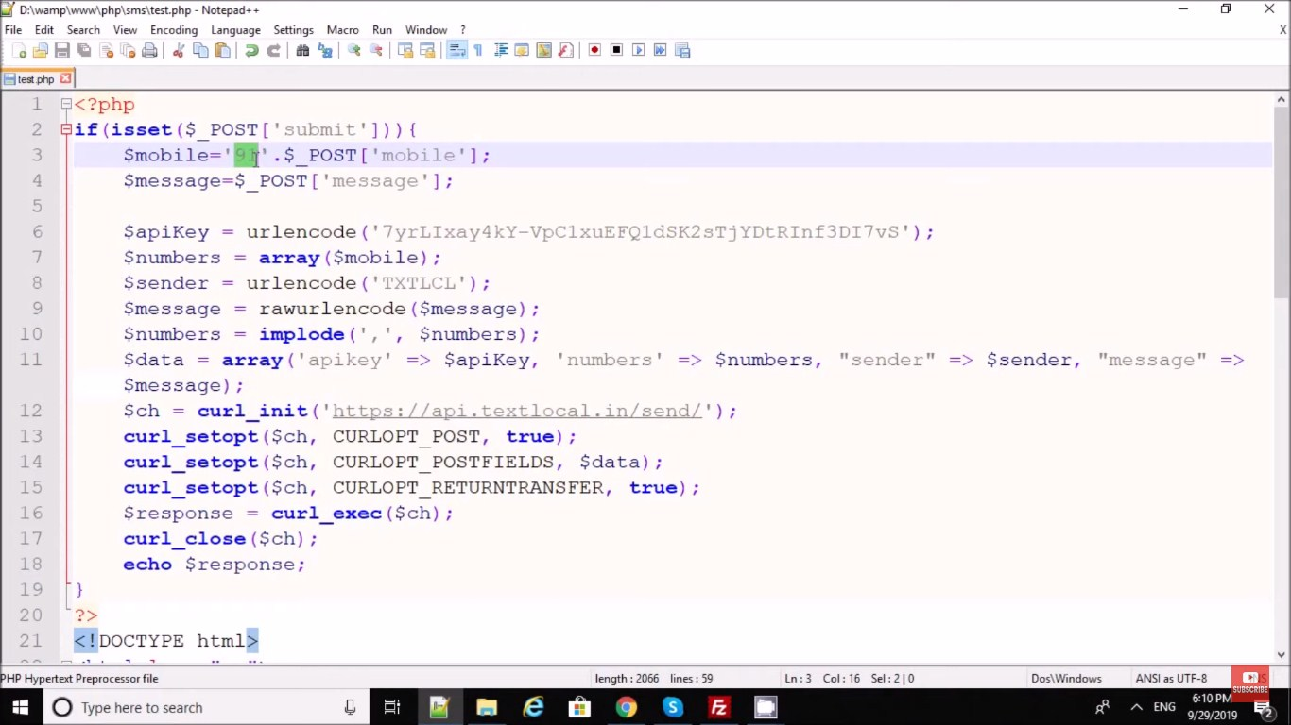**

#### index.php

<!DOCTYPE html>

<html lang="en">

<head>

<title>Send Message</title>

<meta charset="utf-8">

<meta name="viewport" content="width=device-width, initial-scale=1">

<link rel="stylesheet" href="https://maxcdn.bootstrapcdn.com/bootstrap/4.1.3/css/bootstrap.min.css">

<script src="https://ajax.googleapis.com/ajax/libs/jquery/3.3.1/jquery.min.js"></script>

<script src="https://cdnjs.cloudflare.com/ajax/libs/popper.js/1.14.3/umd/popper.min.js"></script>

<script src="https://maxcdn.bootstrapcdn.com/bootstrap/4.1.3/js/bootstrap.min.js"></script>

</head>

<body>

<div class="container">

<h2>Send Message</h2>

<p id="message"></p>

<div class="form-group">

<label for="email">Sender ID:</label>

<input type="email" class="form-control" id="senderid" placeholder="Enter Sender ID" name="senderid">

</div>

<div class="form-group">

<label for="pwd">Mobile No.:</label>

<input type="text" class="form-control" id="mobile" placeholder="Enter Mobile No" name="mobile">

</div>

<div class="form-group">

<label for="comment">Message:</label>

<textarea class="form-control" rows="5" id="message" name="Message" placeholder="Write Your Message Here...."></textarea>

</div>

<button type="submit" class="btn btn-primary" id="send">Send Message</button>

</div>

<script>

$("#send").click(function(){

$.ajax({

type: "POST",

url: "process.php",

data:{

senderid: $('#senderid').val(),

mobile: $('#mobile').val(),

message: $('#message').val()

},

success: function(data){

var objJSON = JSON.parse(data);

$('#message').html(objJSON.message);

}

});

});

</script>

</body>

</html>

#### process.php

<?php

$senderID = $\_POST['senderid'];

$mobile = $\_POST['mobile'];

$message = $\_POST['message'];

/\*MESSAGE CODE\*/

/\* Your authentication key \*/

$authKey = "234557688009432n";

/\* Multiple mobiles numbers separated by comma \*/

$mobileNumber = $mobile;

/\* Sender ID,While using route4 sender id should be 6 characters long. \*/

$senderId = $senderID;

/\* Your message to send, Add URL encoding here. \*/

$message = urlencode($message);

/\* Define route \*/

$route = "route=4";

/\* Prepare you post parameters \*/

$postData = array(

'authkey' => $authKey,

'mobiles' => $mobileNumber,

'message' => $message,

'sender' => $senderId,

'route' => $route

);

/\* API URL\*/

$url="https://www.fast2sms.com/dev/bulk";

/\* init the resource \*/

$ch = curl\_init();

curl\_setopt\_array($ch, array(

CURLOPT\_URL => $url,

CURLOPT\_RETURNTRANSFER => true,

CURLOPT\_POST => true,

CURLOPT\_POSTFIELDS => $postData

/\*,CURLOPT\_FOLLOWLOCATION => true \*/

));

/\* Ignore SSL certificate verification \*/

curl\_setopt($ch, CURLOPT\_SSL\_VERIFYHOST, 0);

curl\_setopt($ch, CURLOPT\_SSL\_VERIFYPEER, 0);

/\* get response \*/

$output = curl\_exec($ch);

/\* Print error if any \*/

if(curl\_errno($ch))

{

echo 'error:' . curl\_error($ch);

}

else{

$array = array(

"message" => $output

);

}

curl\_close($ch);

//MESSAGE CODE END

print json\_encode($array);

?>

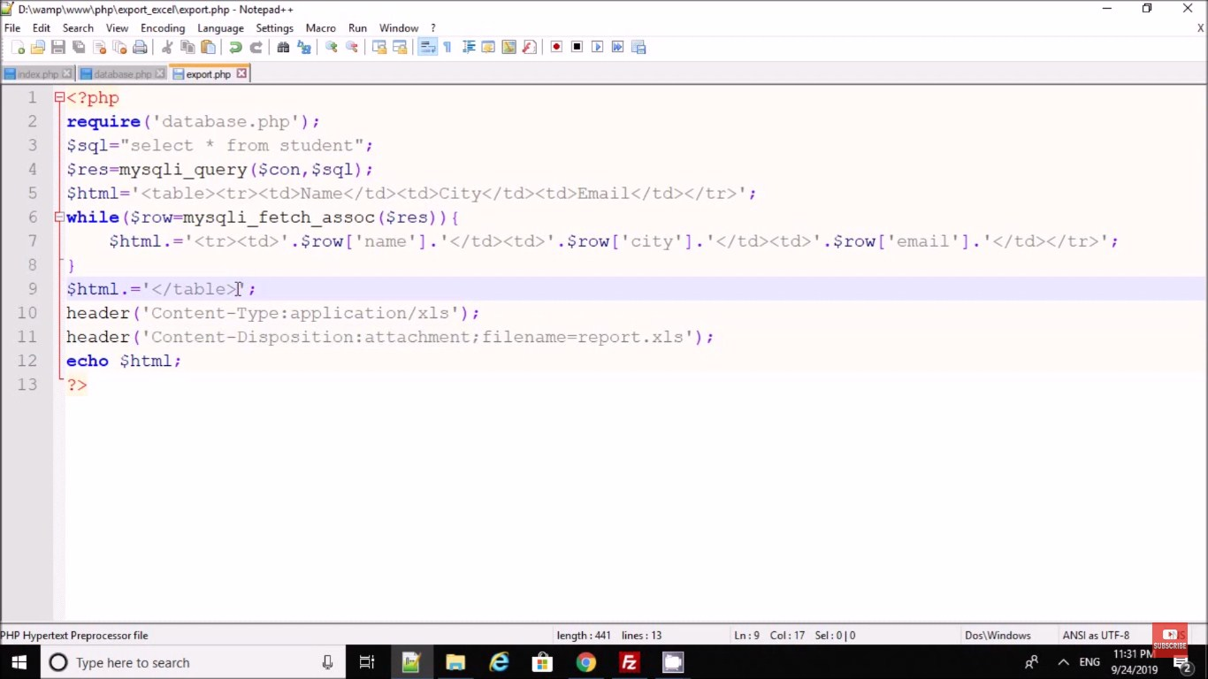

# PHP oops login

CREATE TABLE `users` (

`id` int(11) NOT NULL,

`username` varchar(30) NOT NULL AUTO\_INCREMENT,

`password` varchar(30) NOT NULL,

`fname` varchar(100) NOT NULL,

PRIMARY KEY(`id`)

) ENGINE=InnoDB DEFAULT CHARSET=latin1;

INSERT INTO `users` (`id`, `username`, `password`, `fname`) VALUES

(1, 'neovic', 'devierte', 'Neovic Devierte'),

(2, 'gemalyn', 'cepe', 'Gemalyn Cepe');

#### connection.php

<?php

class DbConnection{

private $host = 'localhost';

private $username = 'root';

private $password = '';

private $database = 'test';

protected $connection;

public function \_\_construct(){

if (!isset($this->connection)) {

$this->connection = new mysqli($this->host, $this->username, $this->password, $this->database);

if (!$this->connection) {

echo 'Cannot connect to database server';

exit;

}

}

return $this->connection;

}

}

?>

#### user.php

<?php

include\_once('DbConnection.php');

class User extends DbConnection{

public function \_\_construct(){

parent::\_\_construct();

}

public function check\_login($username, $password){

$sql = "SELECT \* FROM users WHERE username = '$username' AND password = '$password'";

$query = $this->connection->query($sql);

if($query->num\_rows > 0){

$row = $query->fetch\_array();

return $row['id'];

}

else{

return false;

}

}

public function details($sql){

$query = $this->connection->query($sql);

$row = $query->fetch\_array();

return $row;

}

public function escape\_string($value){

return $this->connection->real\_escape\_string($value);

}

}

#### index.php

<?php

session\_start();

if(isset($\_SESSION['user'])){

header('location:home.php');

}

?>

<!DOCTYPE html>

<html>

<head>

<title>PHP oops login</title>

<link href="https://maxcdn.bootstrapcdn.com/bootstrap/3.3.7/css/bootstrap.min.css" rel="stylesheet">

</head>

<body>

<div class="container">

<h1 class="page-header text-center">PHP oops login</h1>

<div class="row">

<div class="col-md-4 col-md-offset-4">

<div class="login-panel panel panel-primary">

<div class="panel-heading">

<h3 class="panel-title"><span class="glyphicon glyphicon-lock"></span> Login

</h3>

</div>

<div class="panel-body">

<form method="POST" action="login.php">

<fieldset>

<div class="form-group">

<input class="form-control" placeholder="Username" type="text" name="username" autofocus required>

</div>

<div class="form-group">

<input class="form-control" placeholder="Password" type="password" name="password" required>

</div>

<button type="submit" name="login" class="btn btn-lg btn-primary btn-block"><span class="glyphicon glyphicon-log-in"></span> Login</button>

</fieldset>

</form>

</div>

</div>

<?php

if(isset($\_SESSION['message'])){

?>

<div class="alert alert-info text-center">

<?php echo $\_SESSION['message']; ?>

</div>

<?php

unset($\_SESSION['message']);

}

?>

</div>

</div>

</div>

</body>

</html>

#### login.php

<?php

session\_start();

include\_once('User.php');

$user = new User();

if(isset($\_POST['login'])){

$username = $user->escape\_string($\_POST['username']);

$password = $user->escape\_string($\_POST['password']);

$auth = $user->check\_login($username, $password);

if(!$auth){

$\_SESSION['message'] = 'Invalid username or password';

header('location:index.php');

}

else{

$\_SESSION['user'] = $auth;

header('location:home.php');

}

}

else{

$\_SESSION['message'] = 'You need to login first';

header('location:index.php');

}

?>

#### home.php

<?php

session\_start();

if (!isset($\_SESSION['user']) ||(trim ($\_SESSION['user']) == '')){

header('location:index.php');

}

include\_once('User.php');

$user = new User();

$sql = "SELECT \* FROM users WHERE id = '".$\_SESSION['user']."'";

$row = $user->details($sql);

?>

<!DOCTYPE html>

<html>

<head>

<title>PHP OOPS Login</title>

<link href="https://maxcdn.bootstrapcdn.com/bootstrap/3.3.7/css/bootstrap.min.css" rel="stylesheet">

</head>

<body>

<div class="container">

<h1 class="page-header text-center">PHP OOPS Login</h1>

<div class="row">

<div class="col-md-4 col-md-offset-4">

<h2>Welcome to Homepage </h2>

<h4>User Info: </h4>

<p>Name: <?php echo $row['fname']; ?></p>

<p>Username: <?php echo $row['username']; ?></p>

<p>Password: <?php echo $row['password']; ?></p>

<a href="logout.php" class="btn btn-danger"><span class="glyphicon glyphicon-log-out"></span> Logout</a>

</div>

</div>

</div>

</body>

</html>

#### logout.php

<?php

session\_start();

session\_destroy();

header('location:index.php');

?>

# PHP oops login

CREATE TABLE `tblusers` (

`id` int(11) NOT NULL,

`FullName` varchar(120) DEFAULT NULL,

`Username` varchar(120) DEFAULT NULL,

`UserEmail` varchar(200) DEFAULT NULL,

`Password` varchar(250) DEFAULT NULL,

`RegDate` timestamp NULL DEFAULT CURRENT\_TIMESTAMP

) ENGINE=InnoDB DEFAULT CHARSET=latin1;

### function.php

<?php

define('DB\_SERVER','localhost');

define('DB\_USER','root');

define('DB\_PASS' ,'');

define('DB\_NAME', 'userdb');

class DB\_con

{

function \_\_construct()

{

$con = mysqli\_connect(DB\_SERVER,DB\_USER,DB\_PASS,DB\_NAME);

$this->dbh=$con;

if (mysqli\_connect\_errno())

{

echo "Failed to connect to MySQL: " . mysqli\_connect\_error();

}

}

public function usernameavailblty($uname) {

$result =mysqli\_query($this->dbh,"SELECT Username FROM tblusers WHERE Username='$uname'");

return $result;

}

public function registration($fname,$uname,$uemail,$pasword)

{

$ret=mysqli\_query($this->dbh,"insert into tblusers(FullName,Username,UserEmail,Password) values('$fname','$uname','$uemail','$pasword')");

return $ret;

}

public function signin($uname,$pasword)

{

$result=mysqli\_query($this->dbh,"select id,FullName from tblusers where Username='$uname' and Password='$pasword'");

return $result;

}

}

?>

Like index.php may be

<?php

include\_once('function.php');

$userdata=new DB\_con();

if(isset($\_POST['submit']))

{

$fname=$\_POST['fullname'];

$uname=$\_POST['username'];

$uemail=$\_POST['email'];

$pasword=md5($\_POST['password']);

$sql=$userdata->registration($fname,$uname,$uemail,$pasword);

if($sql)

{

echo "<script>alert('Registration successfull.');</script>";

echo "<script>window.location.href='signin.php'</script>";

}

else

{

echo "<script>alert('Something went wrong. Please try again');</script>";

echo "<script>window.location.href='signin.php'</script>";

}

}

?>

<!DOCTYPE html>

<html lang="en">

<head>

<meta charset="utf-8">

<!-- This file has been downloaded from Bootsnipp.com. Enjoy! -->

<title>User Registration using PHP OOPs Concept</title>

<meta name="viewport" content="width=device-width, initial-scale=1">

<link href="assests/style.css" rel="stylesheet">

<script src="assests/jquery-1.11.1.min.js"></script>

<script src="assests/bootstrap.min.js"></script>

<script>

function checkusername(va) {

$.ajax({

type: "POST",

url: "check\_availability.php",

data:'username='+va,

success: function(data){

$("#usernameavailblty").html(data);

}

});

}

</script>

</head>

<body>

<form class="form-horizontal" action='' method="POST">

<fieldset>

<div id="legend" align="center">

<legend class="">User Registration using PHP OOPs Concept</legend>

</div>

<div class="control-group">

<!-- Fullname -->

<label class="control-label" for="username">Fullname</label>

<div class="controls">

<input type="text" id="username" name="fullname" placeholder="" class="input-xlarge" required="true">

</div>

</div>

<div class="control-group">

<!-- Username -->

<label class="control-label" for="username">Username</label>

<div class="controls">

<input type="text" id="username" name="username" onblur="checkusername(this.value)" class="input-xlarge" required="true">

<span id="usernameavailblty"></span>

</div>

</div>

<div class="control-group">

<!-- E-mail -->

<label class="control-label" for="email">E-mail</label>

<div class="controls">

<input type="email" id="email" name="email" placeholder="" class="input-xlarge" required="true">

</div>

</div>

<div class="control-group">

<!-- Password-->

<label class="control-label" for="password">Password</label>

<div class="controls">

<input type="password" id="password" name="password" placeholder="" class="input-xlarge" required="true">

</div>

</div>

<div class="control-group">

<!-- Button -->

<div class="controls">

<button class="btn btn-success" type="submit" id="submit" name="submit">Register</button>

</div>

</div>

<div class="control-group">

<div class="controls">

Already registered <a href="#">Signin</a>

</div>

</div>

</fieldset>

</form>

<script >

</script>

</body>

</html>

#### check\_availability.php

<?php

include\_once('function.php');

$uusername=new DB\_con();

$uname= $\_POST["username"];

$sql=$uusername->usernameavailblty($uname);

$num=mysqli\_num\_rows($sql);

if($num > 0)

{

echo "<span style='color:red'> Username already associated with another account .</span>";

echo "<script>$('#submit').prop('disabled',true);</script>";

} else{

echo "<span style='color:green'> Unsername available for Registration .</span>";

echo "<script>$('#submit').prop('disabled',false);</script>";

}?>

#### signin.php

<?php

include\_once('function.php');

$userdata=new DB\_con();

if(isset($\_POST['submit']))

{

$fname=$\_POST['fullname'];

$uname=$\_POST['username'];

$uemail=$\_POST['email'];

$pasword=md5($\_POST['password']);

$sql=$userdata->registration($fname,$uname,$uemail,$pasword);

if($sql)

{

echo "<script>alert('Registration successfull.');</script>";

echo "<script>window.location.href='signin.php'</script>";

}

else

{

echo "<script>alert('Something went wrong. Please try again');</script>";

echo "<script>window.location.href='signin.php'</script>";

}

}

?>

<!DOCTYPE html>

<html lang="en">

<head>

<meta charset="utf-8">

<title>User Registration using PHP OOPs Concept</title>

<meta name="viewport" content="width=device-width, initial-scale=1">

<link href="assests/style.css" rel="stylesheet">

<script src="assests/jquery-1.11.1.min.js"></script>

<script src="assests/bootstrap.min.js"></script>

<script>

function checkusername(va) {

$.ajax({

type: "POST",

url: "check\_availability.php",

data:'username='+va,

success: function(data){

$("#usernameavailblty").html(data);

}

});

}

</script>

</head>

<body>

<form class="form-horizontal" action='' method="POST">

<fieldset>

<div id="legend" align="center">

<legend class="">User Registration using PHP OOPs Concept</legend>

</div>

<div class="control-group">

<!-- Fullname -->

<label class="control-label" for="username">Fullname</label>

<div class="controls">

<input type="text" id="username" name="fullname" placeholder="" class="input-xlarge" required="true">

</div>

</div>

<div class="control-group">

<!-- Username -->

<label class="control-label" for="username">Username</label>

<div class="controls">

<input type="text" id="username" name="username" onblur="checkusername(this.value)" class="input-xlarge" required="true">

<span id="usernameavailblty"></span>

</div>

</div>

<div class="control-group">

<!-- E-mail -->

<label class="control-label" for="email">E-mail</label>

<div class="controls">

<input type="email" id="email" name="email" placeholder="" class="input-xlarge" required="true">

</div>

</div>

<div class="control-group">

<!-- Password-->

<label class="control-label" for="password">Password</label>

<div class="controls">

<input type="password" id="password" name="password" placeholder="" class="input-xlarge" required="true">

</div>

</div>

<div class="control-group">

<!-- Button -->

<div class="controls">

<button class="btn btn-success" type="submit" id="submit" name="submit">Register</button>

</div>

</div>

<div class="control-group">

<div class="controls">

Already registered <a href="#">Signin</a>

</div>

</div>

</fieldset>

</form>

<script >

</script>

</body>

</html>

#### welcome.php

<?php

session\_start();

if(strlen($\_SESSION['uid'])=="")

{

header('location:logout.php');

} else {

?><!DOCTYPE html>

<html lang="en">

<head>

<meta charset="utf-8">

<title>User Registraion using PHP OOPs Concept</title>

<meta name="viewport" content="width=device-width, initial-scale=1">

<link href="assests/style.css" rel="stylesheet">

<script src="assests/jquery-1.11.1.min.js"></script>

<script src="assests/bootstrap.min.js"></script>

</head>

<body>

<form class="form-horizontal" action='' method="POST">

<fieldset>

<div id="legend">

<legend class="" align="center">Welcome Back : <?php echo $\_SESSION['fname'];?></legend>

</div>

<div class="control-group" align="center">

<!-- Button -->

<div class="controls">

<a href="logout.php" class="btn btn-success" type="submit" name="signin">Logout</a>

</div>

</div>

</fieldset>

</form>

<script >

</script>

</body>

</html>

<?php } ?>

#### logout.php

<?php

session\_start();

session\_destroy();

header('location:signin.php');

?>

**PHP Caching**

**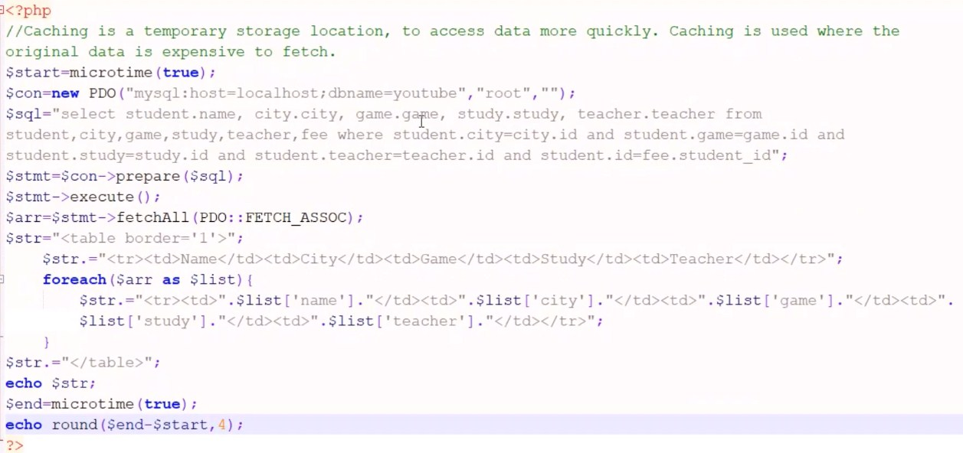**

**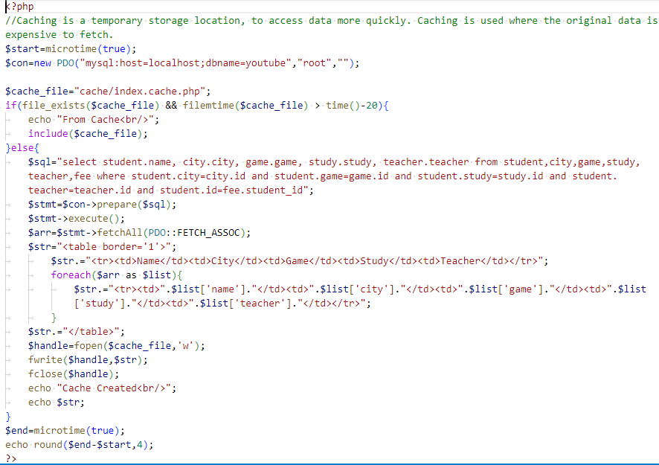**

<?php

//Caching is a temporary storage location, to access data more quickly. Caching is used where the original data is expensive to fetch.

$start=microtime(true);

$con=new PDO("mysql:host=localhost;dbname=youtube","root","");

$cache\_file="cache/index.cache.php";

if(file\_exists($cache\_file) && filemtime($cache\_file) > time()-20){

    echo "From Cache<br/>";

    include($cache\_file);

}else{

    $sql="select student.name, city.city, game.game, study.study, teacher.teacher from student,city,game,study,teacher,fee where student.city=city.id and student.game=game.id and student.study=study.id and student.teacher=teacher.id and student.id=fee.student\_id";

    $stmt=$con->prepare($sql);

    $stmt->execute();

    $arr=$stmt->fetchAll(PDO::FETCH\_ASSOC);

    $str="<table border='1'>";

    $str.="<tr><td>Name</td><td>City</td><td>Game</td><td>Study</td><td>Teacher</td></tr>";

        foreach($arr as $list){

            $str.="<tr><td>".$list['name']."</td><td>".$list['city']."</td><td>".$list['game']."</td><td>".$list['study']."</td><td>".$list['teacher']."</td></tr>";

        }

    $str.="</table>";

    $handle=fopen($cache\_file,'w');

    fwrite($handle,$str);

    fclose($handle);

    echo "Cache Created<br/>";

    echo $str;

}

$end=microtime(true);

echo round($end-$start,4);

?>

**Array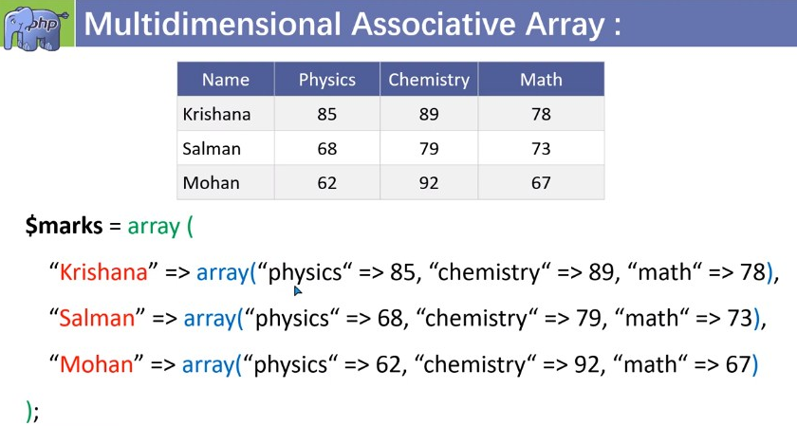**

**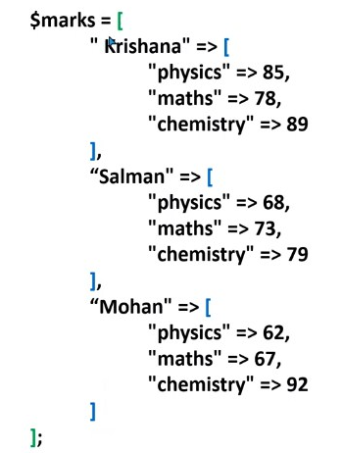**

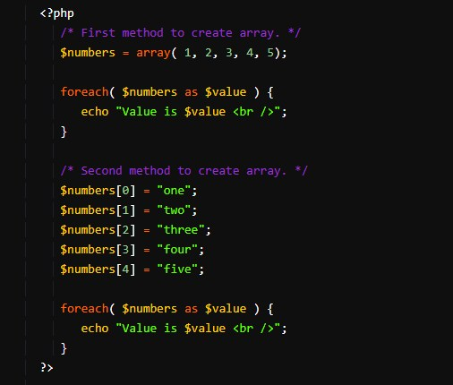

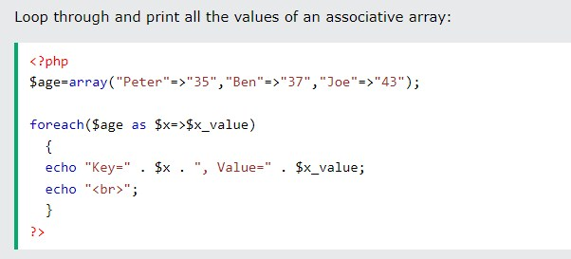

### 

### 

### PHP Array Functions

* **count() - returns the number of elements in an array.**
* **in\_array() - checks if a value exists in an array.**
* **array\_push() - adds one or more elements to the end of an array.**
* **array\_pop() - removes and returns the last element of an array.**
* **array\_shift() - removes and returns the first element of an array.**
* **array\_unshift() - adds one or more elements to the beginning of an array.**
* **array\_reverse() - reverses the order of the elements in an array.**
* **array\_merge() - merges two or more arrays into one array.**
* **array\_slice() - extracts a slice of an array.**
* **array\_splice() - removes and replaces elements from an array.**
* **array\_keys() - returns an array of the keys of an array.**
* **array\_values() - returns an array of the values of an array.**
* **array\_flip() - flips the keys and values of an array.**
* **array\_unique() - removes duplicate values from an array.**
* **array\_search() - searches for a value in an array and returns its key.**
* **array\_rand() - returns one or more random keys from an array.**
* **array\_walk() - applies a user-defined function to each element of an array.**
* **array\_map() - applies a user-defined function to each element of an array and returns a new array with the results.**
* **array\_filter() - filters an array using a user-defined function and returns a new array with the filtered values.**
* **array\_reduce() - reduces an array to a single value using a user-defined function.**
* **array\_column() - returns an array of values from a single column of a multi-dimensional array.**
* **array\_intersect() - returns an array of the values that exist in two or more arrays.**
* **array\_diff() - returns an array of the values that exist in one array but not in another.**

### C:\Users\Rajiv\Desktop\t\Screenshot_20231106-122757_YouTube.jpgC:\Users\Rajiv\Desktop\t\Screenshot_20231106-122944_YouTube.jpgC:\Users\Rajiv\Desktop\t\Screenshot_20231106-123213_YouTube.jpg

### 

### C:\Users\Rajiv\Desktop\Screenshot_1.jpg

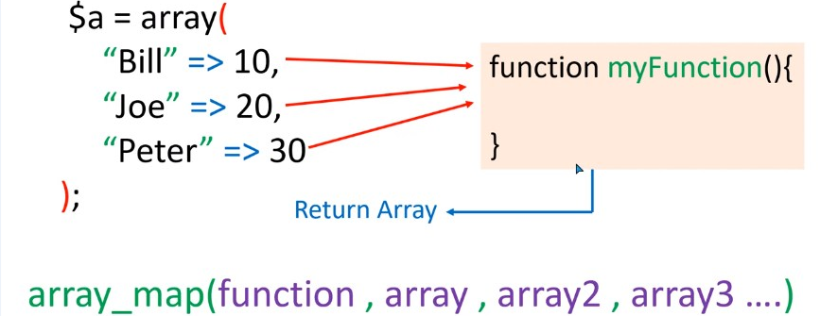

### C:\Users\Rajiv\Desktop\Screenshot_4.jpgC:\Users\Rajiv\Desktop\Screenshot_5.jpg

### C:\Users\Rajiv\Desktop\Screenshot_6.jpg

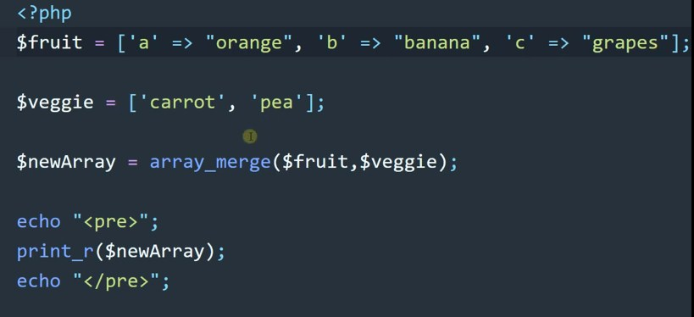

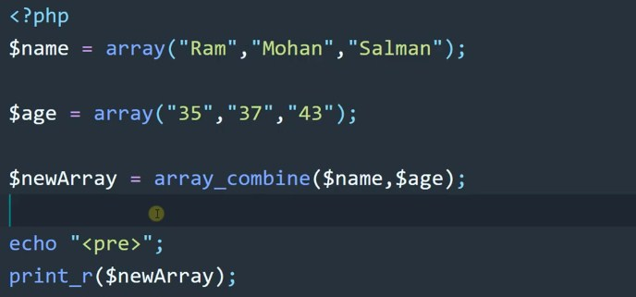

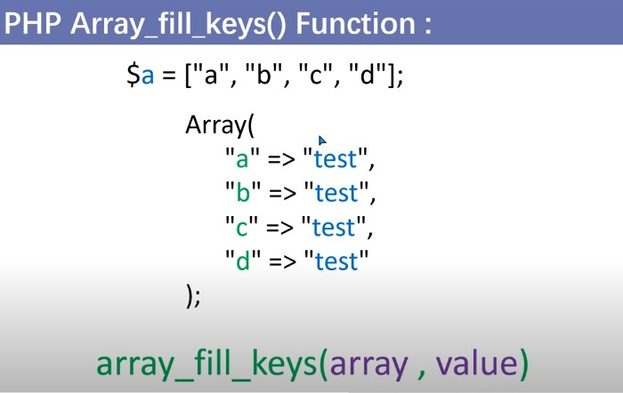

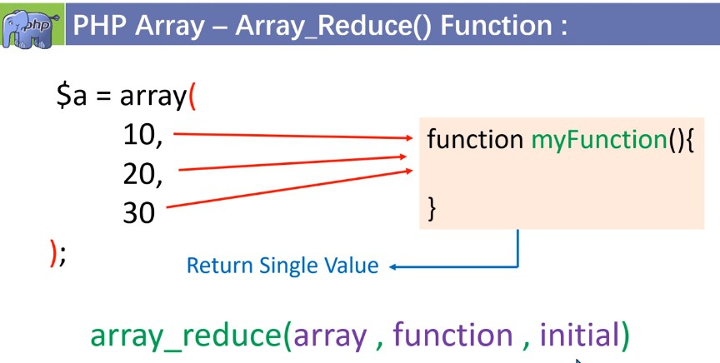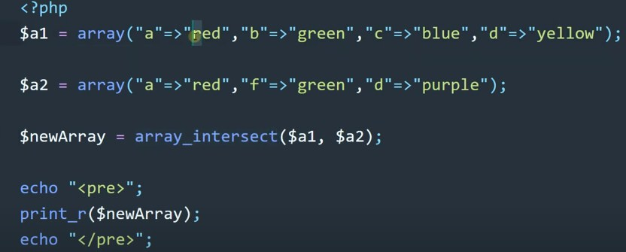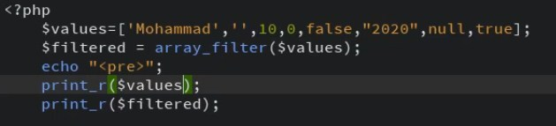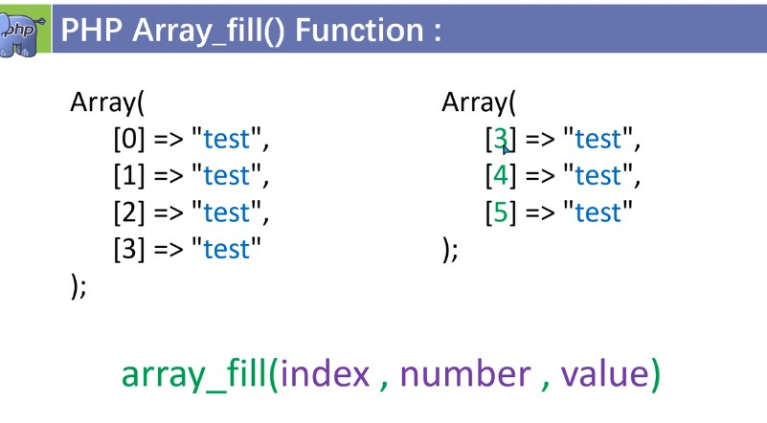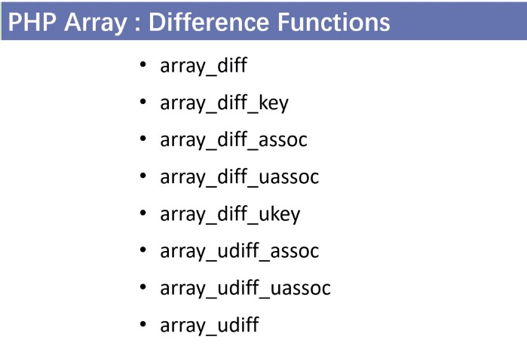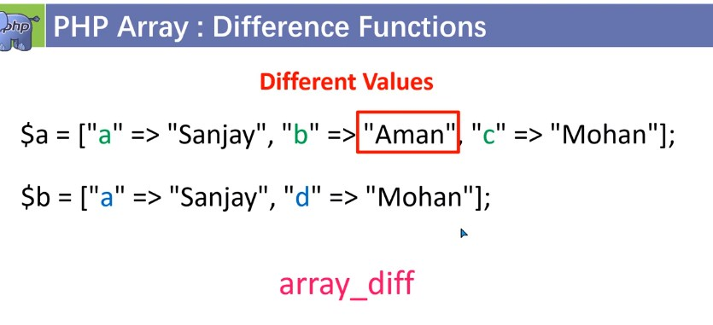

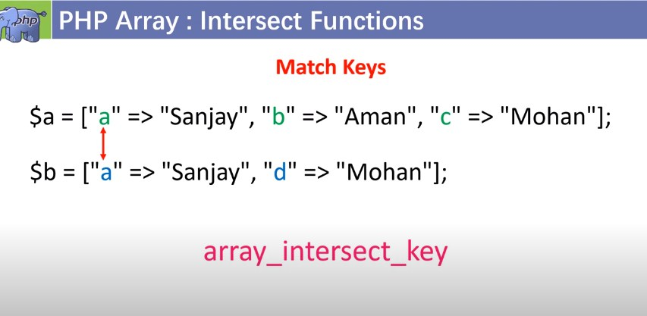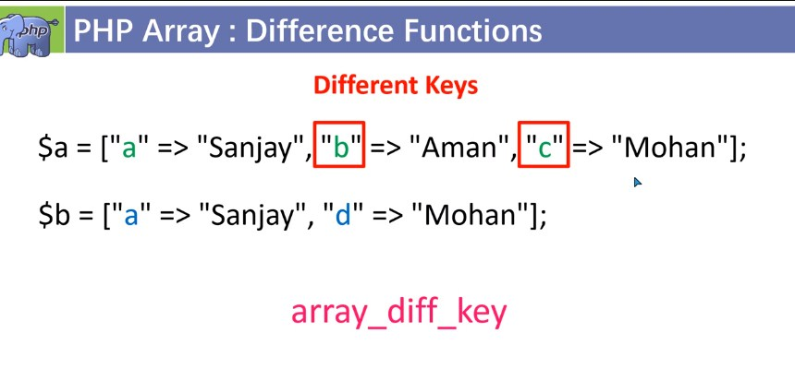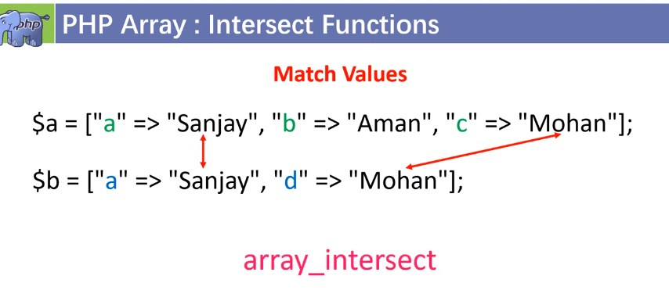

****

****

**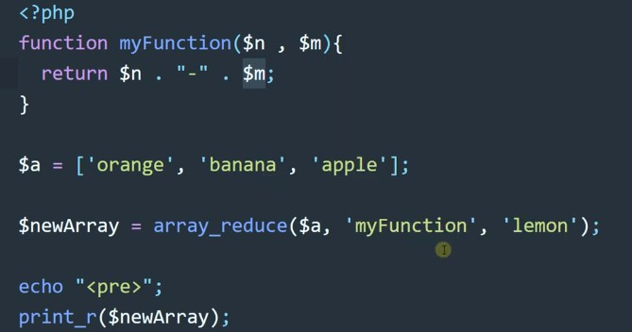**

**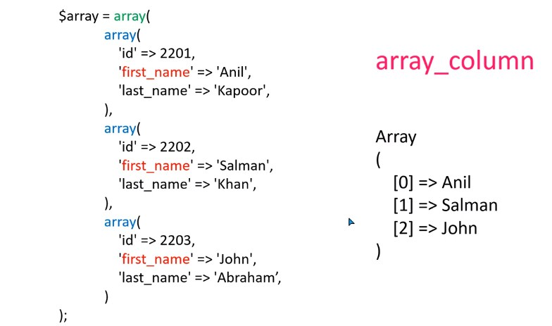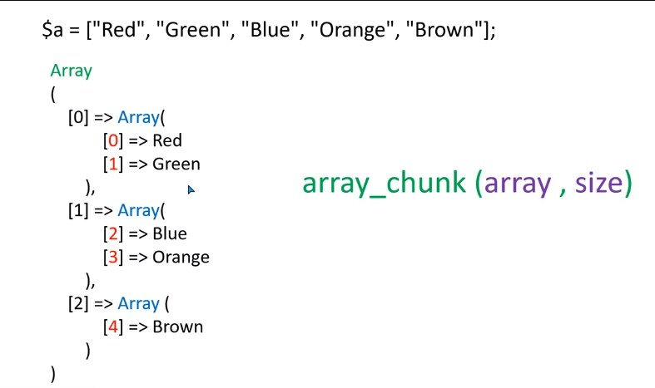**

### String Function

### C:\Users\Rajiv\Desktop\Screenshot_6.jpg

### C:\Users\Rajiv\Desktop\Screenshot_7.jpg

### C:\Users\Rajiv\Desktop\Screenshot_8.jpg

### 

**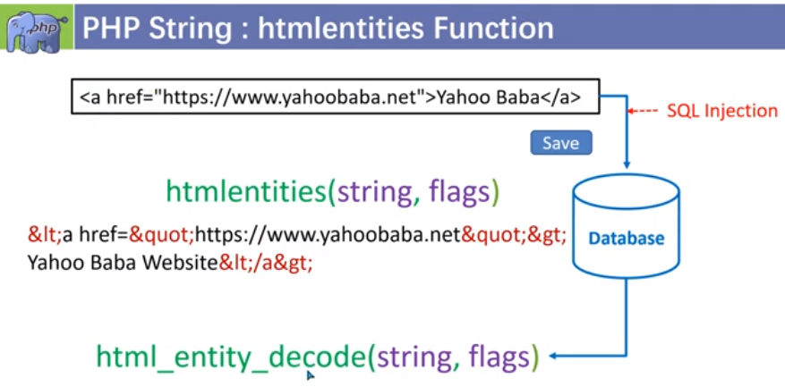**

**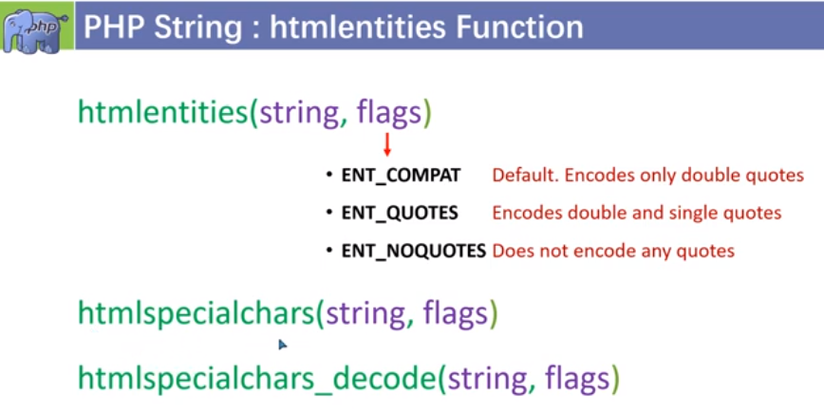**

**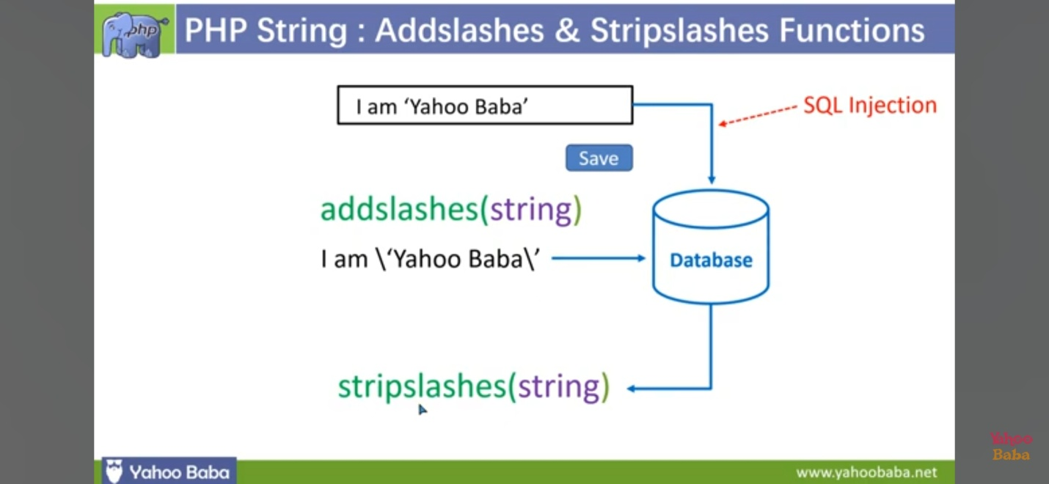**

### C:\Users\Rajiv\Desktop\t\Screenshot_20231106-121121_YouTube.jpgC:\Users\Rajiv\Desktop\t\Screenshot_20231106-122335_YouTube.jpgC:\Users\Rajiv\Desktop\t\Screenshot_20231106-123858_YouTube.jpg

### C:\Users\Rajiv\Desktop\t\Screenshot_20231106-121814_YouTube.jpgC:\Users\Rajiv\Desktop\t\Screenshot_20231106-122010_YouTube.jpgC:\Users\Rajiv\Desktop\t\Screenshot_20231106-122157_YouTube.jpgC:\Users\Rajiv\Desktop\t\Screenshot_20231106-124005_YouTube.jpgC:\Users\Rajiv\Desktop\t\Screenshot_20231106-124023_YouTube.jpg

### 